
Nov. 9th Butte Co. Staffing
Nov. 11th Veteran’s Day
Nov. 12th SDHSA Meeting in Chamberlain
Nov. 18th Policy Council Meeting
Nov. 19th TREC Board Meeting
Nov. 19th Buffalo, Bison, Lemmon Staffing
Nov. 19th Oglala Lakota/Bennett Socials
Nov. 20th Oglala Lakota/Bennett Staffing
Nov. 26th Thanksgiving
Nov. 26th – 27th No School at Centers
Dec. 16th Policy Council Meeting
Dec. 17th TREC Board Meeting
Dec. 7th – 11th Dakota Smiles Dental Bus in Bison
Dec. 14th – 18th Dakota Smiles Dental Bus in Lemmon
Dec. 25th Christmas
Dec. 21st–Jan. 1st No School at Centers

Executive Director: mbevier@badlandshs.org
Education/Disabilities Specialist: mpickle@badlandshs.org
Family Community Specialist: wdunn@badlandshs.org
Health, Nutrition, Safety Specialist: mwolf@badlandshs.org
Mental Health Specialist: rfunk@badlandshs.org

Web Site: http://badlandshs.org/

Newsletter by: Tammy McDaniel -Admin. Assistant
This institution is an equal opportunity provider and employer. 
If you wish to file a Civil Rights program complaint of discrimination, complete the USDA Program Discrimination Complaint Form, found online at http://www.ascr.usda.gov/complaint_filing_cust.html, or at any USDA office, or call (866) 632-9992 to request the form. You may also write a letter containing all of the information requested in the form. Send your completed complaint form or letter to us by mail at U.S. Department of Agriculture, Director, Office of Adjudication, 1400 Independence Avenue, S.W., Washington, D.C. 20250-9410, by fax (202) 690-7442 or email at program.intake@usda.gov.

What’s happening?

A private easy way for South Dakotans to find out if they may qualify for benefits to help meet their family’s needs
Bridge to Benefits is a multi-state project sponsored by South Dakota Voices for Children and the Children’s Defense Fund Minnesota. It is designed to improve the well-being of families and individuals by linking them to public benefit programs and tax credits.
Tax credits and benefit programs were created as a support for children and families that have limited income and resources.
Information about the following assistance programs that can improve the well-being of many families and individuals is available on the South Dakota Bridge to Benefits website:
- Energy Assistance
- Supplemental Nutrition Assistance Program (SNAP, formerly food stamps)
- School Meal Program
- Children’s Health Insurance Program (CHIP)
- Child Care Assistance Program
- Earned Income Tax Credit
- Sales Tax on Food Refund Program
- WIC (Women, Infants, Children) Nutritional Program
To see if you or someone else may be eligible for support programs and tax credits, go to sdbridgetobenefits.org and click on the “start” button.
Benefit eligibility is determined by answering a few simple questions but we will NOT ask you for information that identifies you, such as your name or Social Security number. The screening process is easy, confidential and free! The site can be accessed from any computer, including those at public libraries throughout the state.

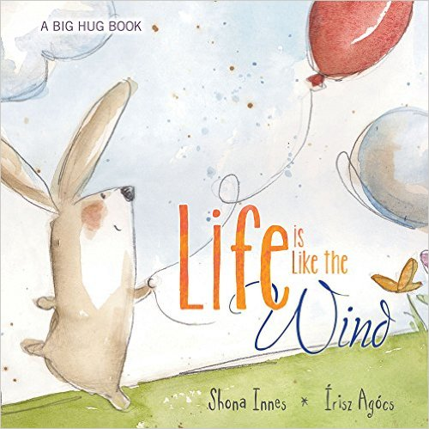

Your Parent Resource Library is a wealth of information!
We will be highlighting a book, DVD, or other resource from the Parent Library each newsletter. Check out a book or other resource and let us know if there is a book or resource we should add to the Parent Library! (Not all materials listed are at all sites.)

Wanda Dunn
Family Community Specialist


Written by: Shelley Moore Thomas
Photographed by: Eric Futran
Get ready—a new baby is coming to your house, and there are going to be lots of changes. Mommy's stomach will get bigger, and there won't be as much room for you on her lap. But you can pat her tummy and feel when it moves in funny ways. The baby will sleep most of the time, and your mommy may tell you "Shhhh." Sometimes the baby will cry—loudly. That's just the way it says "Feed me!" or "Hold me!" or "Change my diaper." As a big brother or sister, you can help with many things and have fun teaching the baby everything you know.

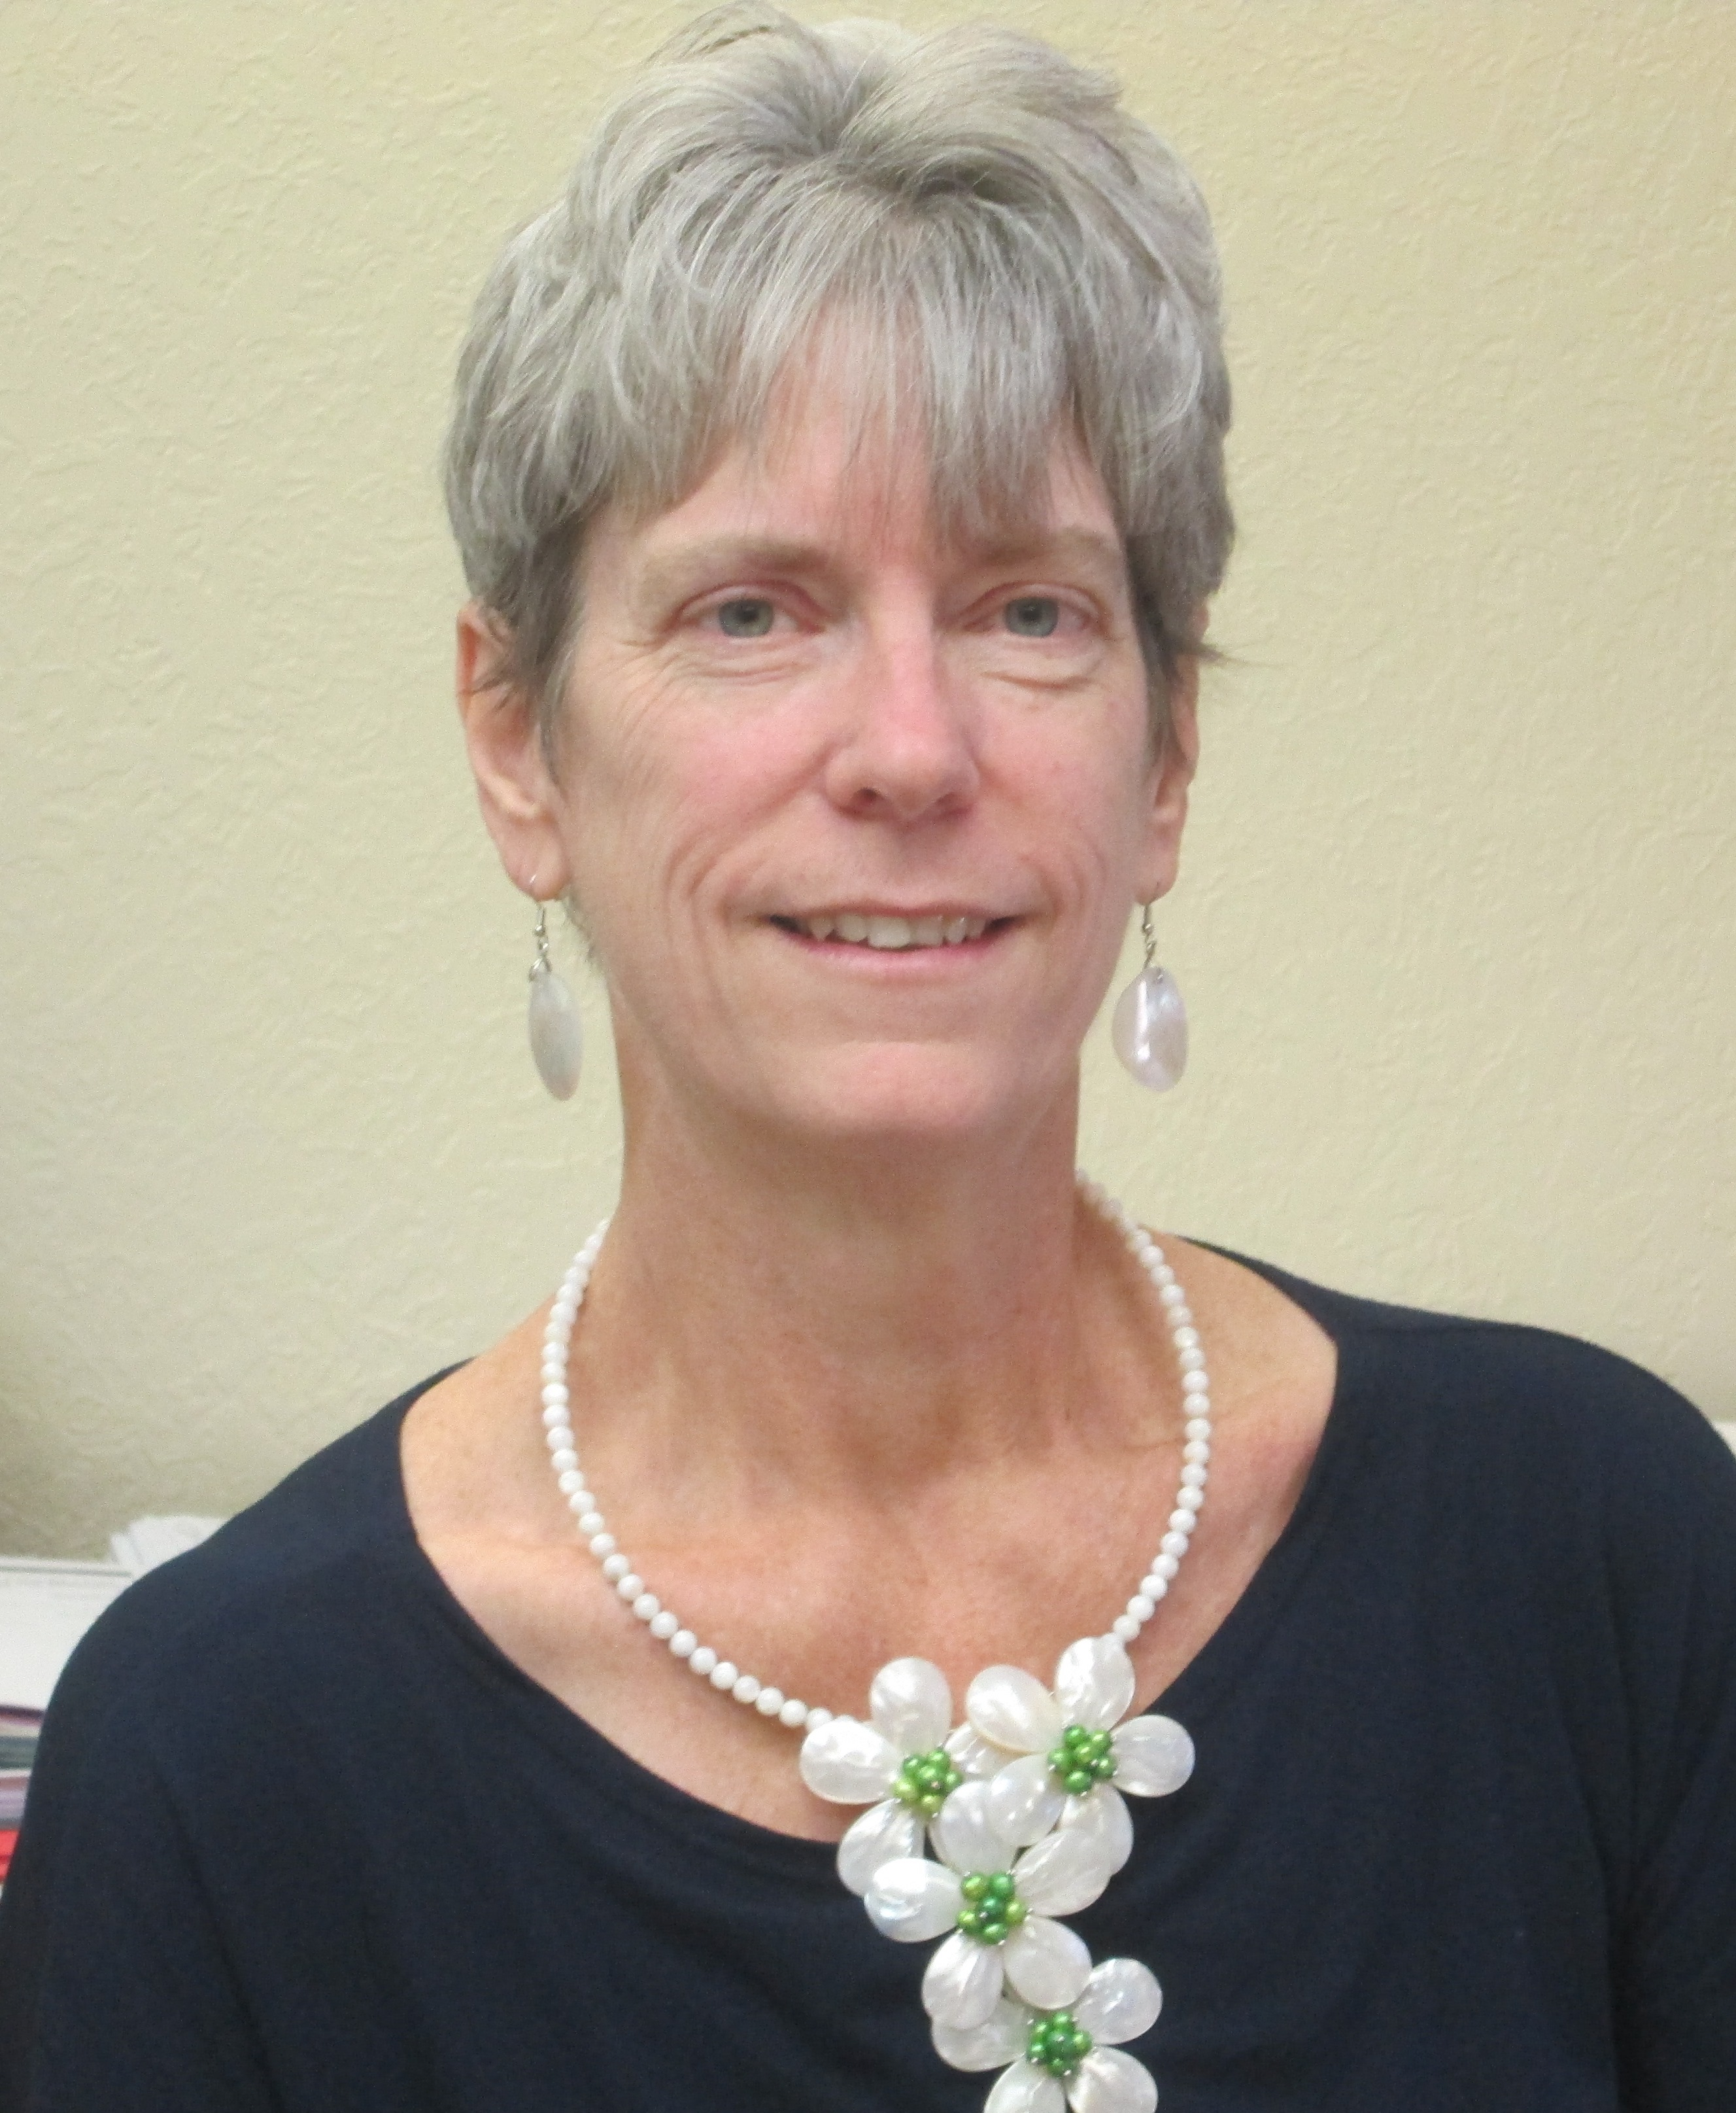
Narrative taken from www.amazon.com

Written by: Shona Innes * Irisz Agocs
Barron's A Big Hug series offers a gentle and direct approach to the emotional issues that children face. Written by a clinical child psychologist, these books encourage youngsters to share and discuss tough topics with family and friends.
Life is Like the Wind introduces the concept of death to young readers by likening life to the ever-moving wind. When the wind is present, things move and fly and flutter about. When the wind goes away, things become very still.
"Life is like the wind.
When life goes away, the body is very still;
the body cannot move or feel
or do anything anymore.
Where does life go when it goes from the body?"
From there, the authors explore the feelings we have when a loved one's life goes away, how we cope with missing them, and how we can celebrate their memory. It also introduces the various things people believe happens to a life that has moved on. Endearing illustrations of animals enjoying, missing, comforting, and honoring one another do a wonderful job of conveying the message that although life is very precious, "when it is time for the life to leave, it will go."
Narrative taken from www.amazon.com

Great Websites for Parents and Children of all ages:
You will find all types of articles to support child growth and development, school readiness, literacy, and many fun activities to enhance the books you read or the television shows that you may watch.
www.RIF.org ; www.pbs.org/parents; www.scholastic.com/parents

Digital Libraries for Kids

If you are looking for free books for kids, you can use not only the public libraries but also a more convenient place – online libraries. If you think they can only offer outdated or not popular books, it’s not true. Below you will find top 4 digital libraries that offer both popular and classic children’s books.
- The Library of Congress is the US oldest federal cultural institution and serves as the research arm of Congress. It is also the largest library in the world, with millions of books, recordings, photographs, maps and manuscripts in its collections. It has a dedicated read.gov page where you can find lots of free online children’s books. This Literature Center at this link http://www.loc.gov/rr/child/.
- Children’s Books Online is a volunteer-driven online library that has thousands of illustrated classic books for children of all ages. The site gets updated each week. The link to this site is http://www.childrensbooksonline.org.
- Magic Keys is a small digital library that offers a quality collection of illustrated books for children of all ages. All books can be read for free. Some of the books have audio versions as well. The link to this site is http://www.magickeys.com.
- TheIBLibrary is a digital library of new books and best-sellers. This online library is especially popular among teachers looking for quality children’s books and Amazon best-sellers. You can read all the books for free and there is no charge whatsoever. The link to children’s books at this site is www.theiblibrary.com/books-list/.

Sing with your Child
Singing songs with your child is a great way to help build your child’s language skills, whether your child is a newborn infant or is getting ready to transition into kindergarten. Here are a couple of fun songs to sing with your child for this time of year.

All the Leaves Are Falling Down (By Diane Chancy)
Tune: “London Bridges Falling Down”

All the leaves are falling down, falling down, falling down (Imitate leaves falling down)
All the leaves are falling down, it is fall.
Take the rake and rake them up, rake them up, rake them up (Imitate raking leaves)
Take the rake and rake them up, it is fall.
Make a pile and jump right in, jump right in, jump right in, (Children jump forward)
Make a pile and jump right in, it is fall.


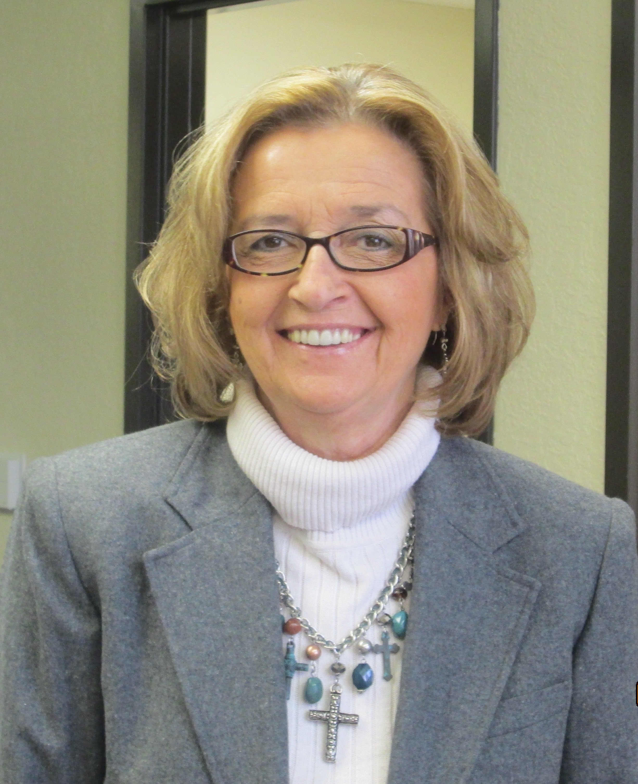
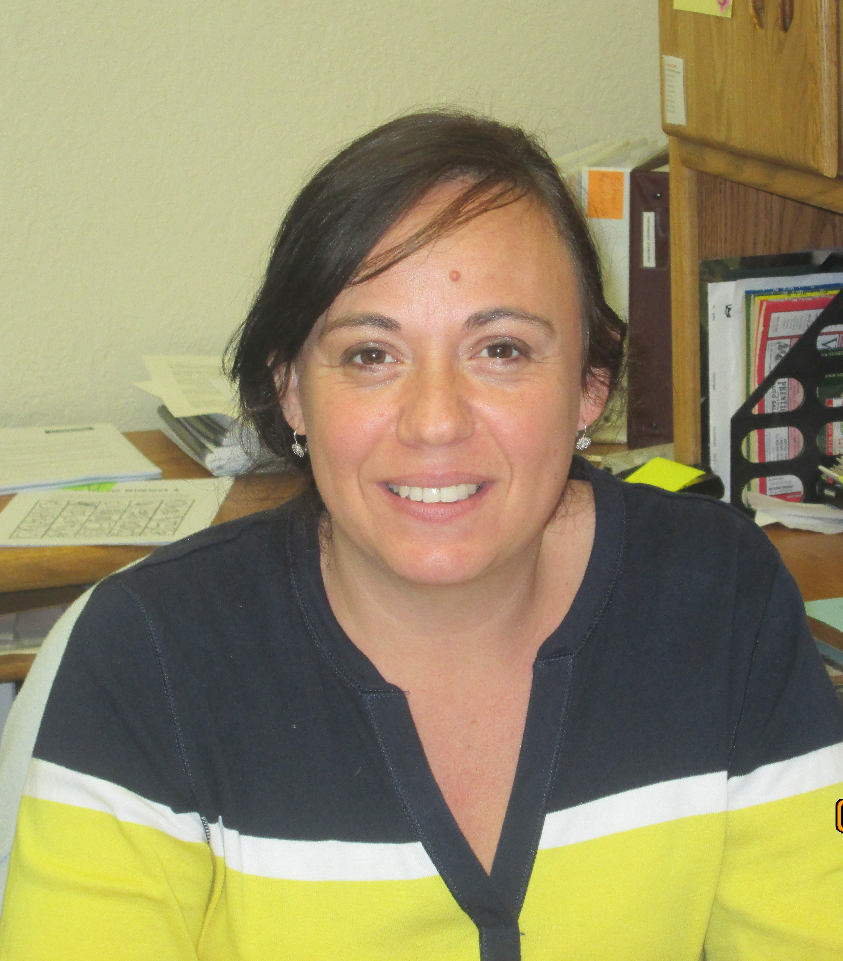
Recipe

Peanut Butter Muffins
Prep Time: 35 Minutes
Ingredients:
- 2 eggs
- 1 c. milk
- ¼ c. banana (about 1 banana), mashed with a fork
- ¼ c. peanut butter
- 1/3 c. vegetable oil
- ¼ c. frozen apple juice concentrate, thawed (left out of the freezer until it’s soft)
- ¼ c. nonfat dry milk
- 2 ¼ c. flour
- 1 ½ tsp. baking powder
- 1 tsp. baking soda
- Nonstick cooking spray
Utensils:
- Oven (you’ll need help from your adult assistant)
- Fork
- Small bowl
- Large bowl
- Mixing spoon
- Muffin/cupcake tin
- Paper muffin/cupcake liners
- Wire rack
- Measuring cups and spoons
Directions:
- Preheat oven to 350 degrees F (180 degrees C).
- In a small bowl, break the eggs and use a fork to beat them a little bit.
- In a large bowl, combine the milk, mashed banana, peanut butter, vegetable oil, apple juice, dry milk, and the eggs from the small bowl. Mix with a mixing spoon until the mixture is creamy.
- Add the flour, baking powder, and baking soda into the large bowl. Mix again.
- Line a muffin tin with paper liners or lightly spray with nonstick spray. Spoon in the muffin mix. Fill each muffin cup about 2/3 of the way up.
- Bake for about 15 minutes.
- When your muffins are finished baking, remove from muffin tin and cool them on the wire rack. Then it’s time to taste and share!
Serves: 12
Serving Size: 1 muffin
Nutritional analysis (per serving) 214 calories; 6 g protein; 10 g fat; 25 g carbohydrate; 1 g fiber; 36 mg cholesterol; 223 mg sodium; 81 mg calcium; 1.3 mg iron

© 1995- 2015 The Nemours Foundation/Kids Health® Reprinted with permission.

Malynda Wolf – Health, Nutrition & Safety Specialist
Hazel Vilhauer – Health-Safety Coordinator


Talking with your Child
Your child was born to learn! From birth, your child is learning language and ways to express himself! Learning language will help your child be a good reader and writer. With your help, she will do better in school. Try these easy and fun activities with your child:

Your Infant:
- Talk to your baby all day long. Feeding and dressing tie s are great times to talk to your child. Use short simple sentences: “Mmmm. Good bananas! Do you want more?”
- Play with your baby every day. Play peek-a-boo. Wait for her to smile, laugh, repeat your voice sounds, or cover her face with her hands. Then do it again.
- Sing songs like “itsy Bitsy Spider” and “Pat-a-Cake.” Your baby will love your voice! You can make up your own words and your own songs too!
- Your baby is learning to use her voice to let you know what she needs and wants. Pay attention to her when she cries or makes sounds. Be sure to respond to her cries. Repeat her “words.” Answer her with simple words.

Your Toddler:
- Talk to your child about what you are doing during the day. “I’m washing the dishes. Wash, wash, wash! Can you help?” Let him “help” you with daily chores. Listen for him to repeat your words. Clap and smile when he does.
- Play games with your toddler and his toys. Take turns rolling a ball back and forth. Say words like, “Roll it! Catch it! Throw it!” Clap and smile when she takes turns with you.
- Sing or say nursery rhymes and other rhymes you know or have read. Once your child knows the rhyme, let her finish a line: You say, “Jack and Jill went up the…” and let your child say, “hill.”
- Listen and respond to what your child says. Use simple, clear language. Show your child that you are truly interested: “Yes, that’s a truck. It’s big, isn’t it?”
- Read to your toddler every day. Let your child act out parts of the story. Ask simple questions about the story. Get your child talking about what he remembers.

Your Preschooler:
- Read to your preschooler every day. Ask questions about what happens in the story. Let her guess what she things will happen next.
- Your preschooler is full of questions. Answer them and be sure she understands you. Ask questions back to her. Give her clues to help her answer you.
- Have pretend conversations with you child. Ask your child if she remembers the event. Ask your child to tell you about it. Help your child tell the story by talking about the photo. For example, if the photo is of your child’s birthday party, talk about who was there and what happened at the party: “You had a Thomas the Train Cake. It was chocolate. You loved it!”
- Tell stories to your child. Tell real life stories and stories that you know.

Parent Tips is a monthly resource for parents with your children.
Want more suggestions? Visit www.readyatfive.org
To Yell or Not to Yell?
As parents, we all differ. Some of us parent in a soft spoken voice and lead from behind in a quiet still manner. While others of us are loud, more boisterous and lead from the front lines. Maybe this is just the way we are and how we were raised. If we ourselves are raised in a loud family with lots of noise and yelling, this becomes normal to us as we don’t know anything different. Typically, children become accustom to their parents volume and the emotional climate of their own home. A family can be loud and children can still feel safe and loved. Most every parent has occasional times when they become overwhelmed and yell at their children and most of the time, little damage is done. So, how do we as parents know when too loud is too loud? How do we know when yelling is hurting our children?
If you’re loud or a yeller by nature and you’re uncertain how this is impacting your family and your child, here are some things to consider and think about. Are you yelling damaging and hurtful things directly at your child? Are you comparing or labeling your child? Belittling or discouraging them? Children develop their self-esteem from their parents. They see themselves through your eyes. Most importantly, it’s about what you say rather than how loud you say it. Keep in mind, children are all individuals and respond differently to yelling. Yelling can be in particularly scary for infants and young children. Research findings show that infants and babies are not oblivious to their parent’s conflicts and long lasting exposure to these conflicts could influence the way in which their brain processes stress and anxiety. Observe your child’s responses. Do they appear overwhelmed and fearful? Do they wince, cry or withdraw? If you are observing any of these signs from your child, you’re yelling and way of communicating may clearly be impacting them.
Families that are always yelling or shouting to be heard, sometimes struggle in teaching or role modeling the art of listening for their children. If each family member is always competing for air space, this can affect a child’s ability to learn how to listen to another person’s feelings and point of view. They may struggle at school or other places when they will be required to listen and respond to others who give directions softly.
Sometimes yelling occurs between spouses and partners as well. As couples, some of us are better at resolving our conflicts in an effective manner. How do you and your partner resolve your conflicts? Is it all about winning and losing or is it about truly resolving the issue and making things better? Remember, we are role modeling healthy relationships for our children too. One day, they will enter a relationship and practice what you have taught them. When your child hears you speak negatively or belittle their mother or father, this hurts as they see each parent as a part of themselves. If you’re struggling in your relationship and arguing in front of your children, try to work your differences out away from them. If it just feels too difficult to resolve your conflicts without yelling and hurting each other, seek additional support from family friends or a counselor.
Rebecka Funk MA. LPC-MH - Mental Health Consultant
Winter Travel
Winter driving can be extremely hazardous at times due to poor road conditions or reduced visibilities from heavy or blowing snow. During these times, travel is difficult and not recommended. Many people still venture outdoors not knowing what they will encounter. Many winter deaths and injuries can be attributed to people becoming stranded and venturing away from their vehicle. To avoid this, you should stay inside your vehicle and wait for help.
When traveling this winter season: Listen to the forecast before departing and postpone travel if inclement weather is occurring or expected; avoid traveling alone; inform others of your timetable and planned routes; keep your gas tank near full; adjust your speed to the conditions and increase following distances; carry a Winter Survival Kit in your vehicle at all times! Items that should be in your Survival Kit: Shovel and flashlight with extra batteries; first aid kit and medications; non-perishable food (such as granola bars and peanuts); candles and matches; extra clothing, sleeping bags, or blankets; jumper cables and tire chains; battery-operated radio; cell phone with fully charged batteries; windshield scraper and brush; brightly colored cloth to tie on the antenna.

Outdoor Educational Fun
Fall is my favorite time of the year. The days are getting cooler, the air feels crisper, and everywhere you look is nearly bursting with color! I hope you take advantage of these changes in the weather to take your child outdoors and to explore of all of the learning opportunities that nature has to offer. Here are just a few ideas to make the most of your time with your child outdoors.

- Leaf Art: Go for a walk with your child to collect leaves of varying sizes, shapes and colors to create a collage. Talk with your child about how the leaves are similar and different from one another, if they feel different from each other, what colors the leaves are, how they are shaped differently, what types of trees they come from, etc. You can use construction paper and glue to create the collages or simply place the leaves on clear contact paper. This activity helps to build your child’s vocabulary, to increase your child’s understanding of the property of leaves, and encourages your child’s creativity.

- Color Walk: Take advantage of the weather by going on a color walk with your child. Pick a color, such as red, and have your child point out all of the things he or she sees in that color. You can talk about all of the different shades of the color during your walk as well as all of the different animals, plants, and items that come in the color too. This activity will not only help your child learn about colors, but also increase his or her ability to observe the world.

- Raking Leaves: You can turn the chore of raking leaves into a fun activity for you and your child. Have your child help you rake leaves into various piles. If you don’t have a child sized rake, have your child use his or her hands to pick up the leaves and carry them to a pile. Talk with your child about the types of leaves being picked up, their colors, sizes, etc. You can also count how many piles of leaves there are and discuss the sizes of each pile, pointing out which ones are bigger and which ones are smaller. Finally, let your child jump into a big pile of leaves! By doing this activity, you are helping your child to develop his or her large muscles, get much needed exercise and to increase his or her vocabulary.
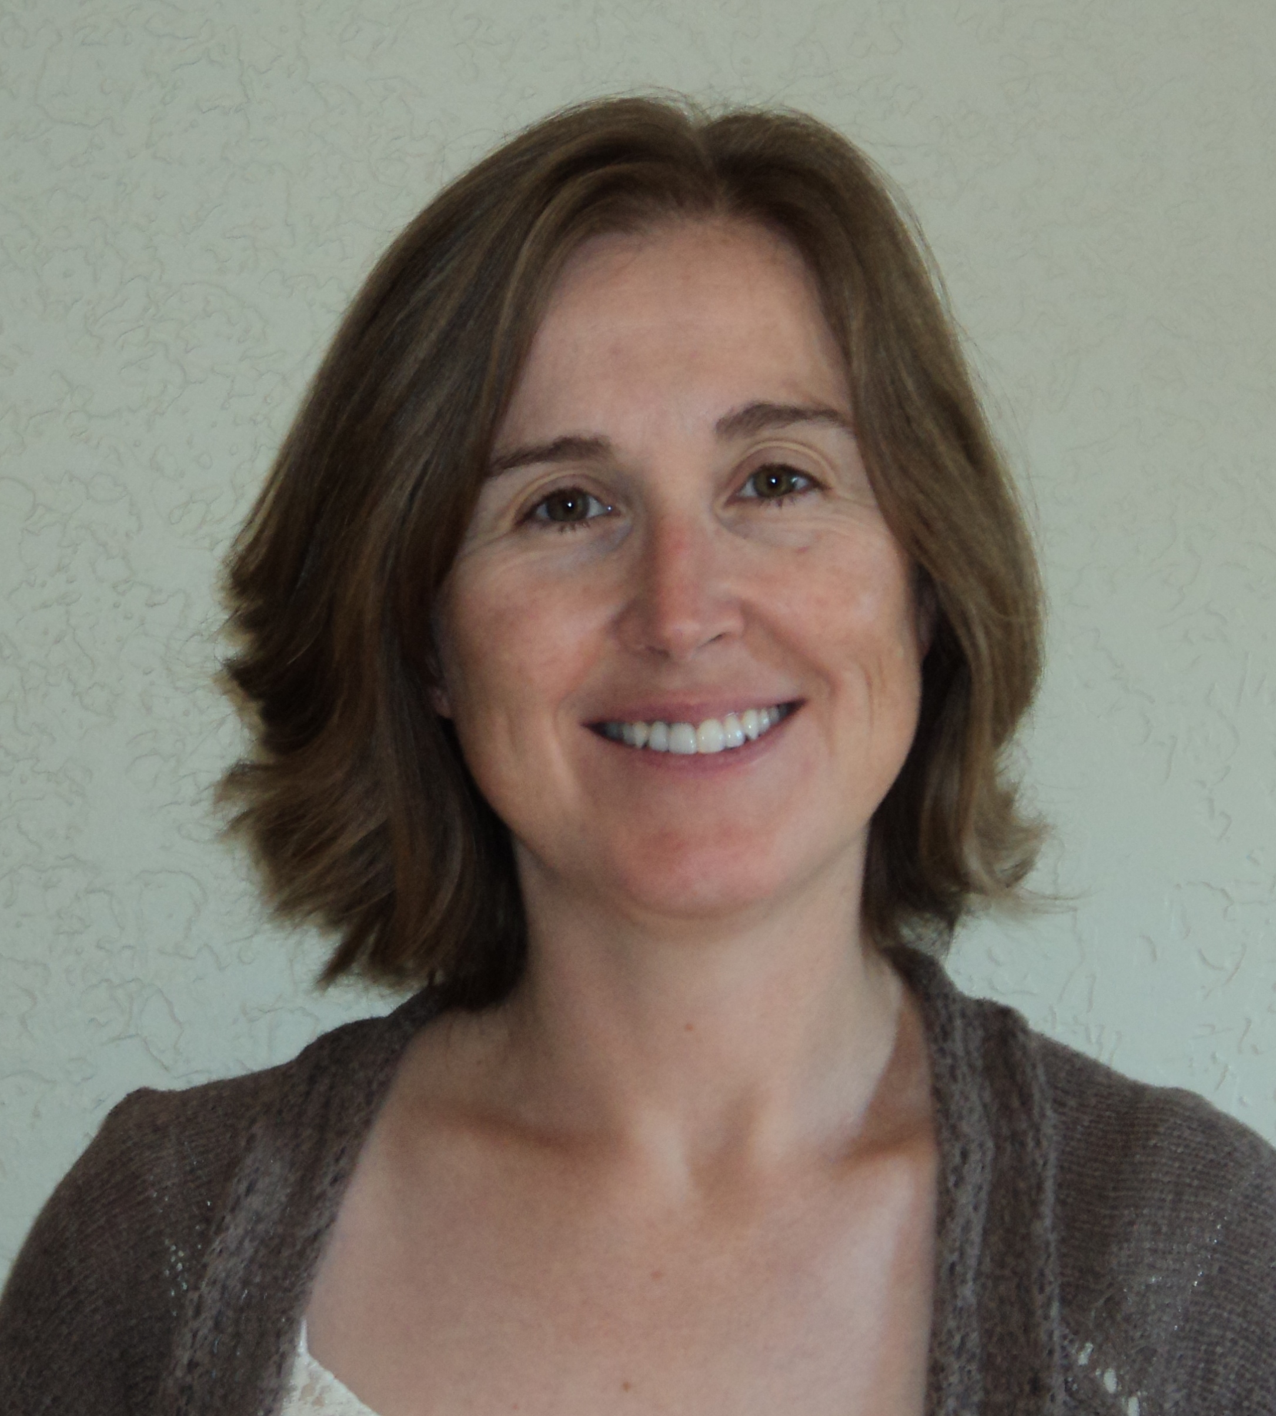
Melissa Pickle
Education/Disabilities Specialist
Everyday Math Words
Taken from: Early Years (Oct. Issue)
Help your child get comfortable with the language of math by weaving math words and phrases into conversations. Here’s how:
- Encourage your youngster to compare quantities and sizes. You could ask, “Are there more people in the first line or the second line?” or “Which glass has less water?” This prepares her to make “greater than,” “less than,” and “equal to” comparisons with numbers and measurements.
- Use phrases that your child will find in story problems, like altogether and take away. (“There are three pictures on this wall. If we take away one picture, how many will be left?”)
- It’s not too early for your little one to begin understanding fractions. Ask her to fold napkins in half, or suggest that she divide her marble collection into four equal sets.

Leaves are falling one by one Hurrah Hurrah!!! That fun fall song runs through my head as I think about all the fall activities that are happening in the Bison and Lemmon centers and on home visits in Harding and Perkins Counties. October is Fire Prevention Month which is recognized through teachers and home visitors conducting fire drills and teaching fire safety.

In the Bison center, we welcome Krista Ellingson as our nutrition support/Early Head Start Home Visitor for Perkins Co. and in Harding Co. we welcome Christina Norman as our EHS home visitor and Julia Lermany as our substitute while Christina is on maternity leave. All three ladies bring experience, knowledge, and enthusiasm to the Head Start team and we are excited to welcome them on board!

We are approaching our 45 day deadline in which hearing, vision, developmental and social emotional screenings need to be completed so the teachers have been working hard to ensure those deadlines are being met as well as developing Individual Child Plans with the parents and completing the TS Gold screenings.

During the Early and Head Start home visits in Harding County, home visitors have incorporated leaves, apples, pumpkins and sensory play into the learning experience. Bison Center students are learning about Community helpers, autumn and harvesting and Lemmon Students are learning about ice melting and the water cycle, nature and pumpkins. We will enjoy the beautiful fall weather as long as we can before we turn our attention to snowflakes, snowmen and Winter safety! Enjoy!

Ruth Adams, Area Services Manager

I cannot believe how fast time is flying by. People have settled into a routine and 45 day deadlines have passed. The weather so far has been great but we all know that won’t last much longer. What I would like to do is give families some fun learning activities that you can do with your children indoors or out. They could be included on the in kind sheet under my activities:
Animal Voices (Teaches about loud and soft)
Talk with your child about animal sounds. Ask her which animals make loud sounds and which make soft. Ask your child to make loud animal sounds and soft ones. Look at pictures of zoo animals and talk about the zoo and the animals.
Frog Sounds (Teaches about languages)
Ask your child to pretend to be a frog, making the sound “ribbit, ribbit.” Explain that children in other countries make different sounds when they pretend to be a frog. Here are some you can try:

Arabic: gar, gar Spanish: crua’, crua’ French: coa-coa German: quaak, quaak Italian: cra, cra
I hope you have fun with these! Next newsletter I will include more for you to try!
Michele Kreuzer-Ranken
Area Services Manager- Butte Co

