,


May 5th OL/B Socials
May 8th Mother’s Day
May 12th SDHSA Meeting in Chamberlain
May 17th Last day for Belle Fourche Center
May 17th Policy Council Meeting
May 18th Last day for Bison Center
May 19th Last day for Lemmon Center
May 19th TREC Board Meeting
May 30th Holiday – Memorial Day

Executive Director: mbevier@badlandshs.org
Education/Disabilities Specialist: mpickle@badlandshs.org
Family Community Specialist: wdunn@badlandshs.org
Health, Nutrition, Safety Specialist: mwolf@badlandshs.org
Mental Health Specialist: rfunk@badlandshs.org

Web Site: http://badlandshs.org/

Newsletter by: Tammy McDaniel -Admin. Assistant
This institution is an equal opportunity provider.

To file a program discrimination complaint, complete the USDA Program Discrimination Complaint Form, AD-3027, found online at http://www.ascr.usda.gov/complaint_filing_cust.html and at any USDA office or write a letter addressed to USDA and provide in the letter all of the information requested in the form. To request a copy of the complaint form, call (866) 632-9992. Submit your completed form or letter to USDA by: (1) mail: U.S. Department of Agriculture, Office of the Assistant Secretary for Civil Rights, 1400 Independence Avenue, S.W., Washington, D.C. 20250-9410, (2) fax: (202) 690-7442 or (3) email: program.intake@usda.gov.

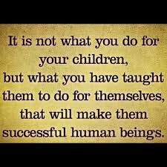
Read to Your Children
Twenty minutes a day;
You have the time, and so do they.

Read while the laundry is in the machine;
Read while dinner cooks;
Tuck a child in the crook of your arm;
And reach for the library books.

Hide the remote,
Let the computer games cool;
For one day your child will be off to school.

Make it fun! You have the choice.
Let them hear their first tales,
In the sound of your voice

Read in the morning,
Read over noon,
Read by the light of
Goodnight Moon.

Turn the pages together,
Sitting close as you’ll fit,
Till a small voice beside you says,
“Please don’t quit.”

Author Unknown


Your Parent Resource Library is a wealth of information!
We will be highlighting a book, DVD, or other resource from the Parent Library each newsletter. Check out a book or other resource and let us know if there is a book or resource we should add to the Parent Library! (Not all materials listed are at all sites.)

Wanda Dunn
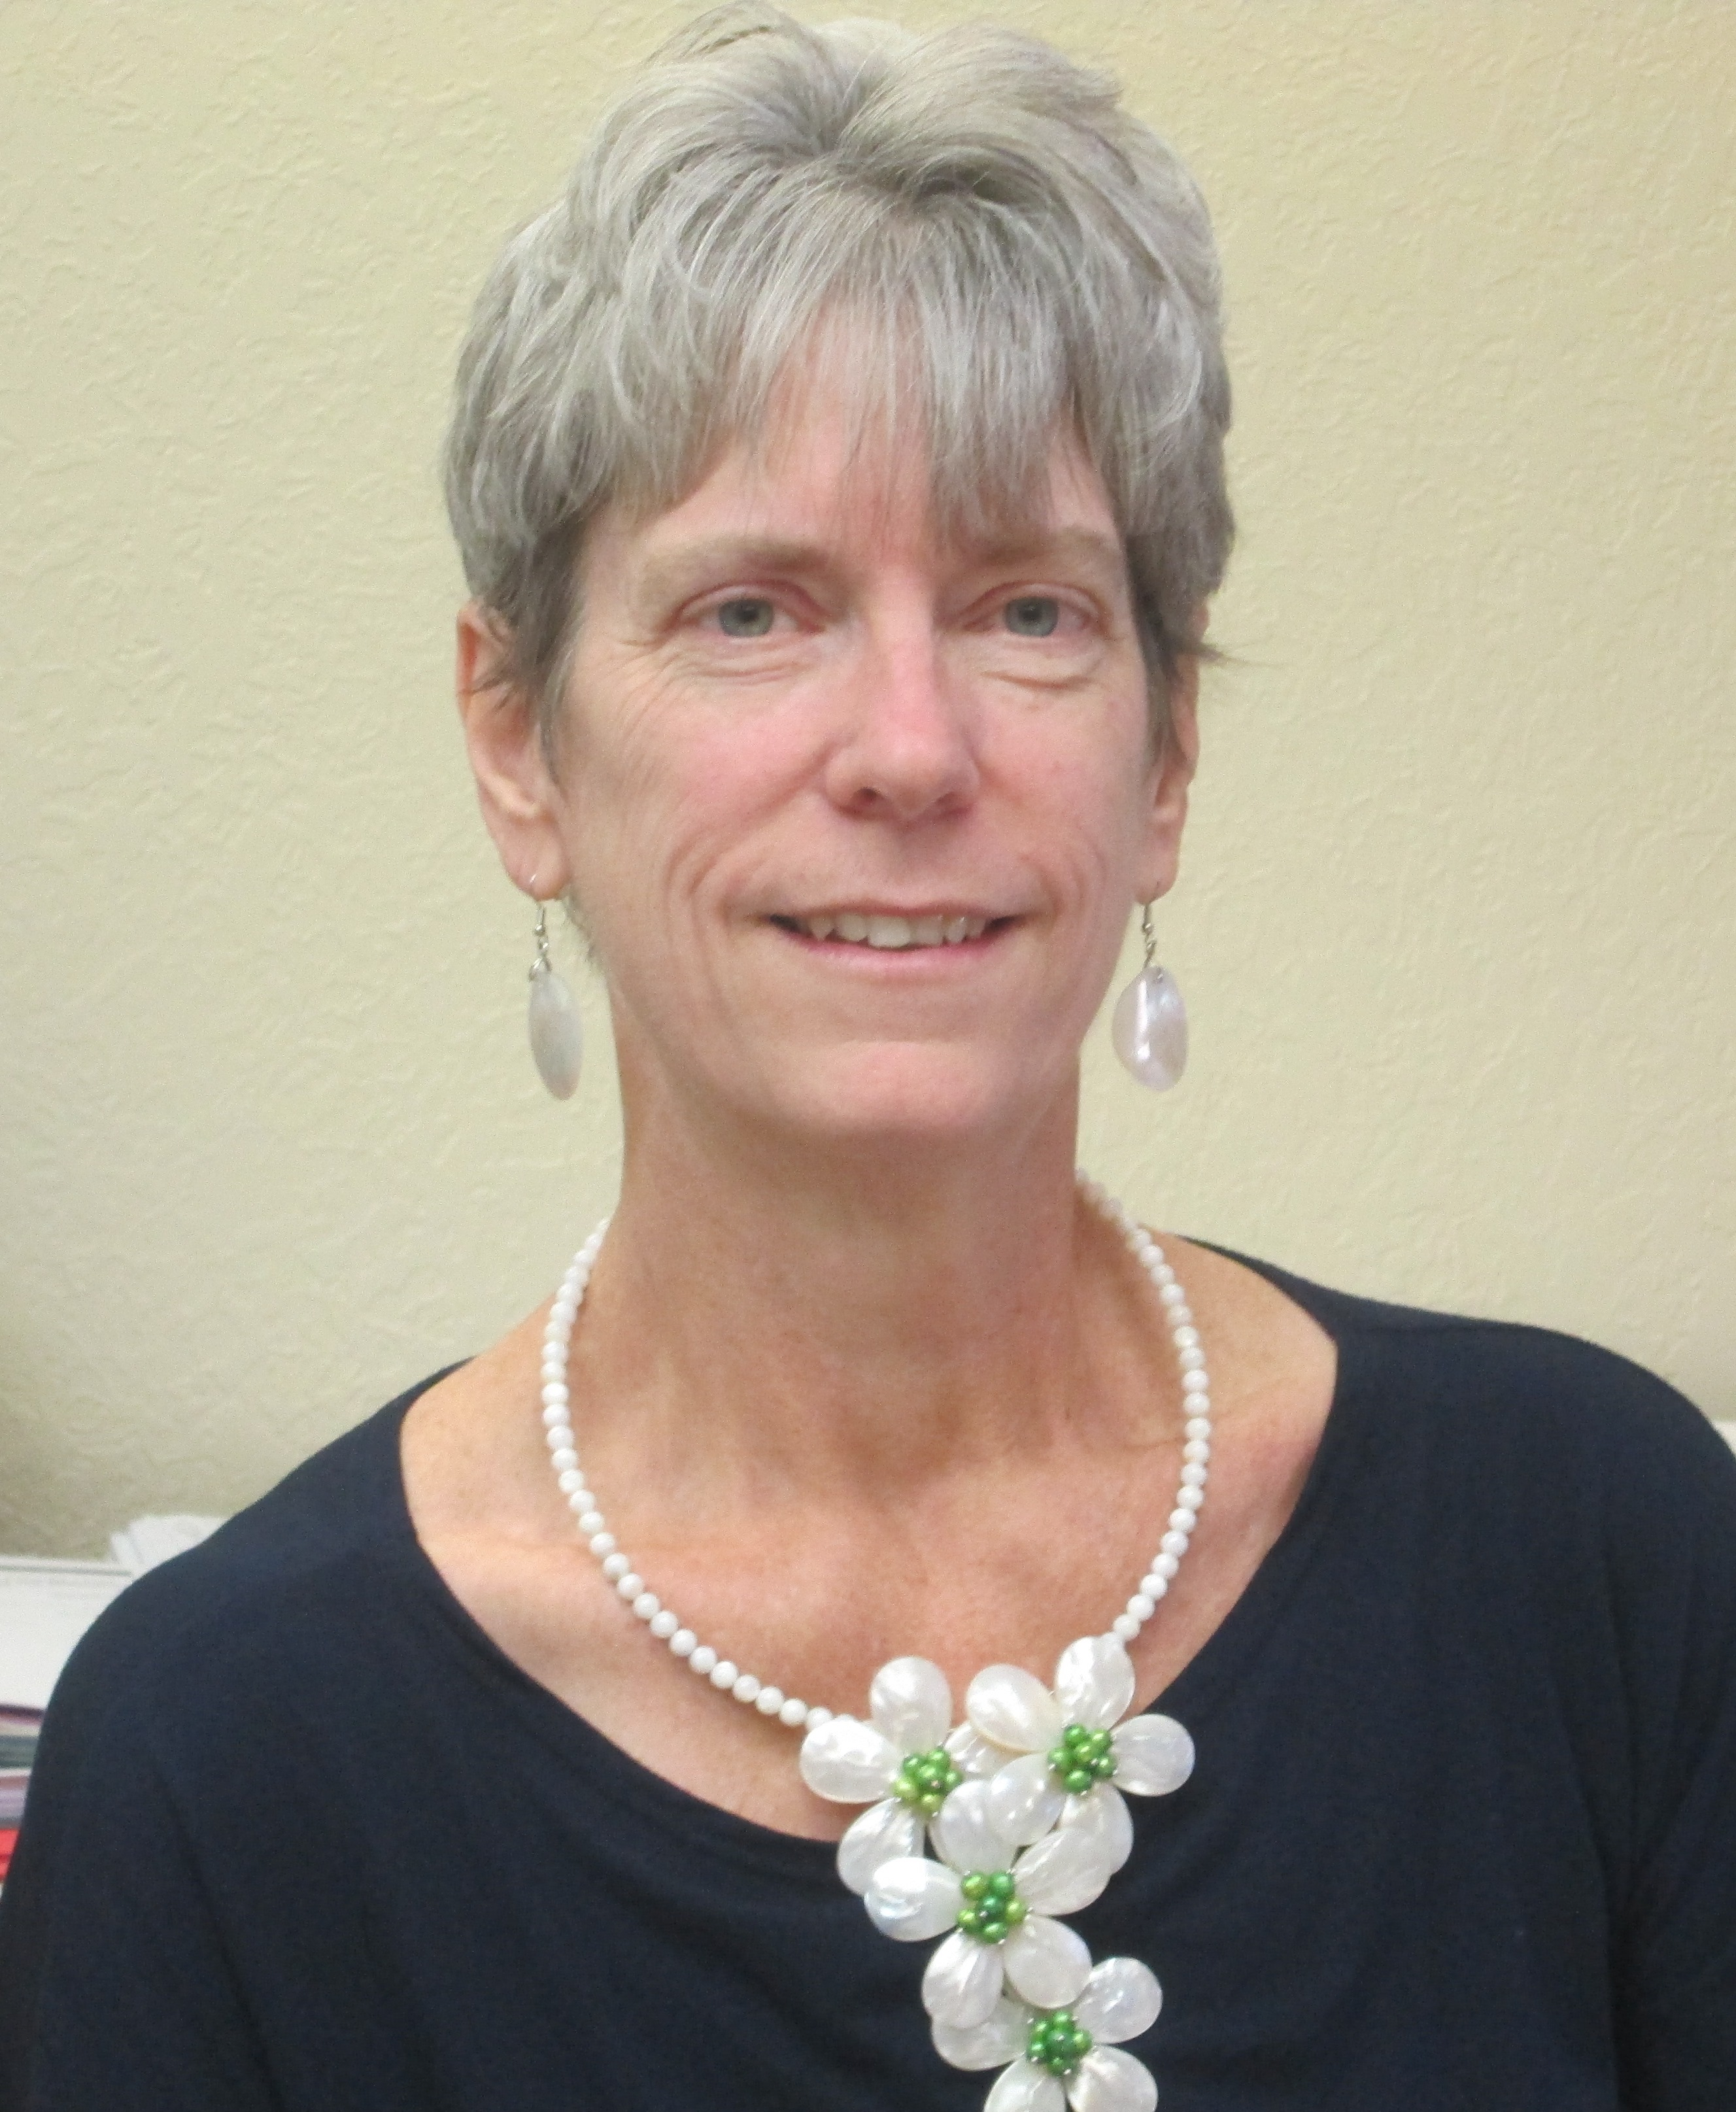
Family Community Specialist

You and Me, Little Bear

In this affectionate picture book about child-adult interaction, the author of this book tells a classic tale about helping and playing. This book rings with familiar feelings for children as it offers parents a gentle reminder to make time to play!
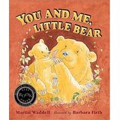

Author: Martin Waddell
Illustrator: Barbara Firth
Pages: 32
Ages: Toddler – 6 yrs. Old
Themes: Responsibility, spending time together

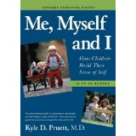

A definitive guide to Toddlerhood – the extraordinary period when parents have the greatest influence in setting their child on a healthy and happy course for life

Nationally-known author Kyle D. Pruett, M.D. draws on the latest research and his decades of experience as a develop-mentalist and child and family psychiatrist. The result is clear, practical help for parents to enhance their child’s growth on all fronts, from language and social skills to cognitive and emotional development. A thorough and engaging guide to:
- Temperament: What it is and how it’s shaped by parenting
- The “oh-so-trying” but “not so terrible” twos: what they are, and basic guidelines for helping parents cope
- Brain development: the latest research and the major but under-appreciated role emotions play
- Discipline: the best ways to set limits by keeping the long-term goal – self-control in the child, not parental control of the child – in mind.

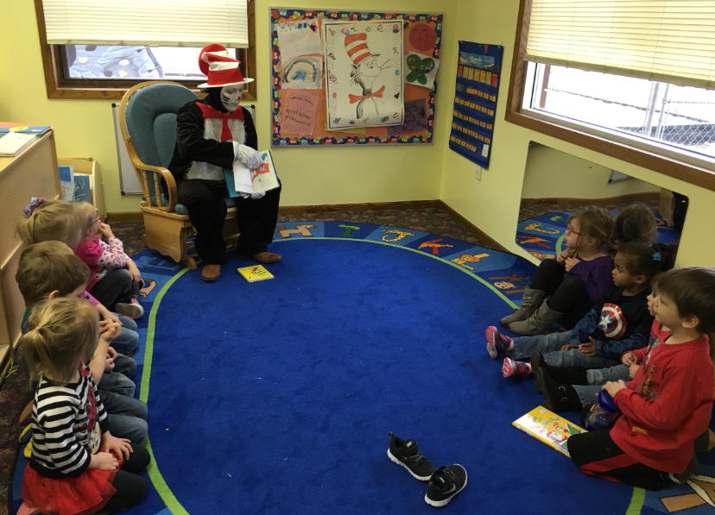
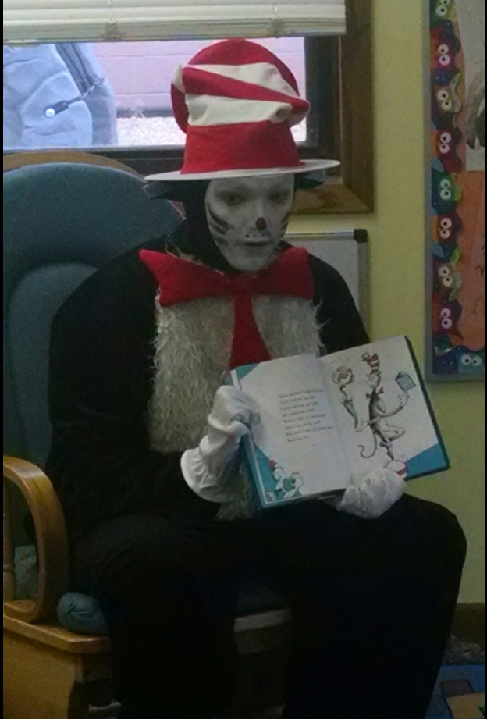
The Cat in the Hat made an appearance again this year at the Belle Fourche Center during the week of Dr. Seuss’s Birthday. (“Thank you Mr. Marcus!”) He was a big hit! Pictured above is the Cat in the Hat reading to Ms. Rosie and Ms. Jenny’s students.
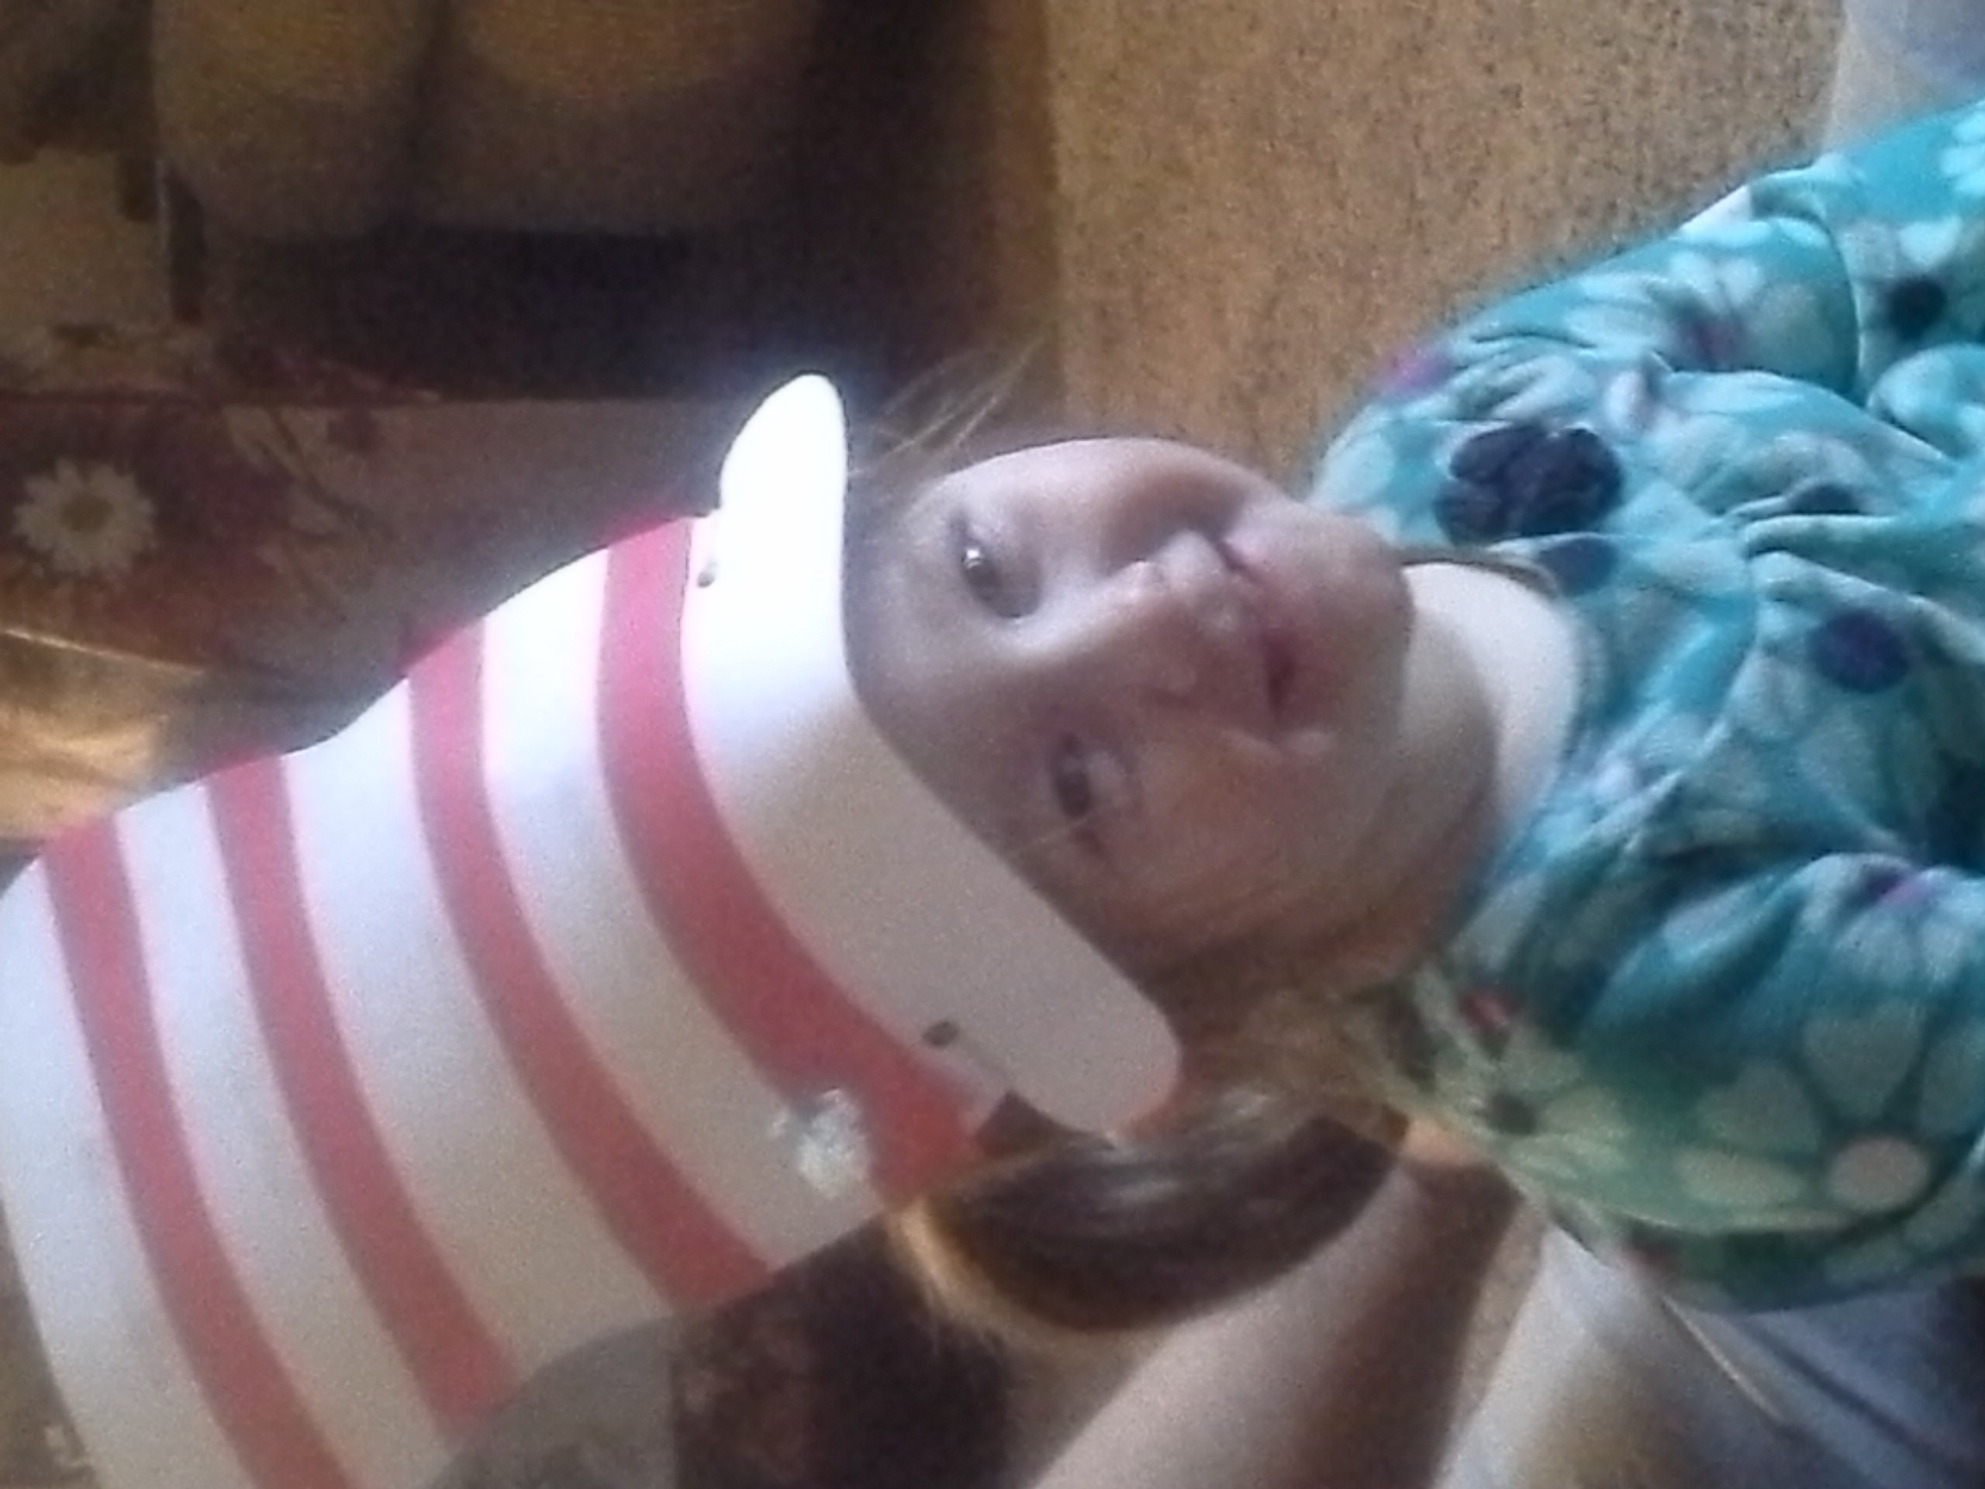
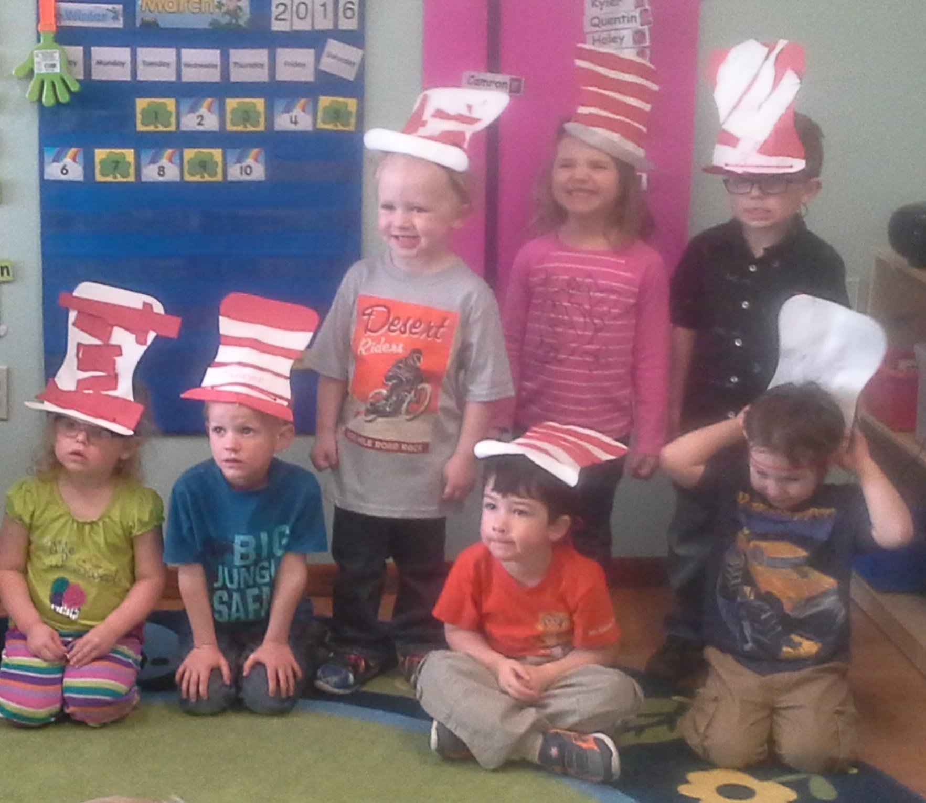
Ms. Pam and Ms. Tori’s students made hats for Dr. Seuss’s birthday as well!

Ms. Pita helped her Early Head Start parents and children make hats for Dr. Seuss’s birthday! Above right: Danielle Quenzer; below from left to right: Rozlynn Vermillion, Nathan Lomelin, and Hope Cazer
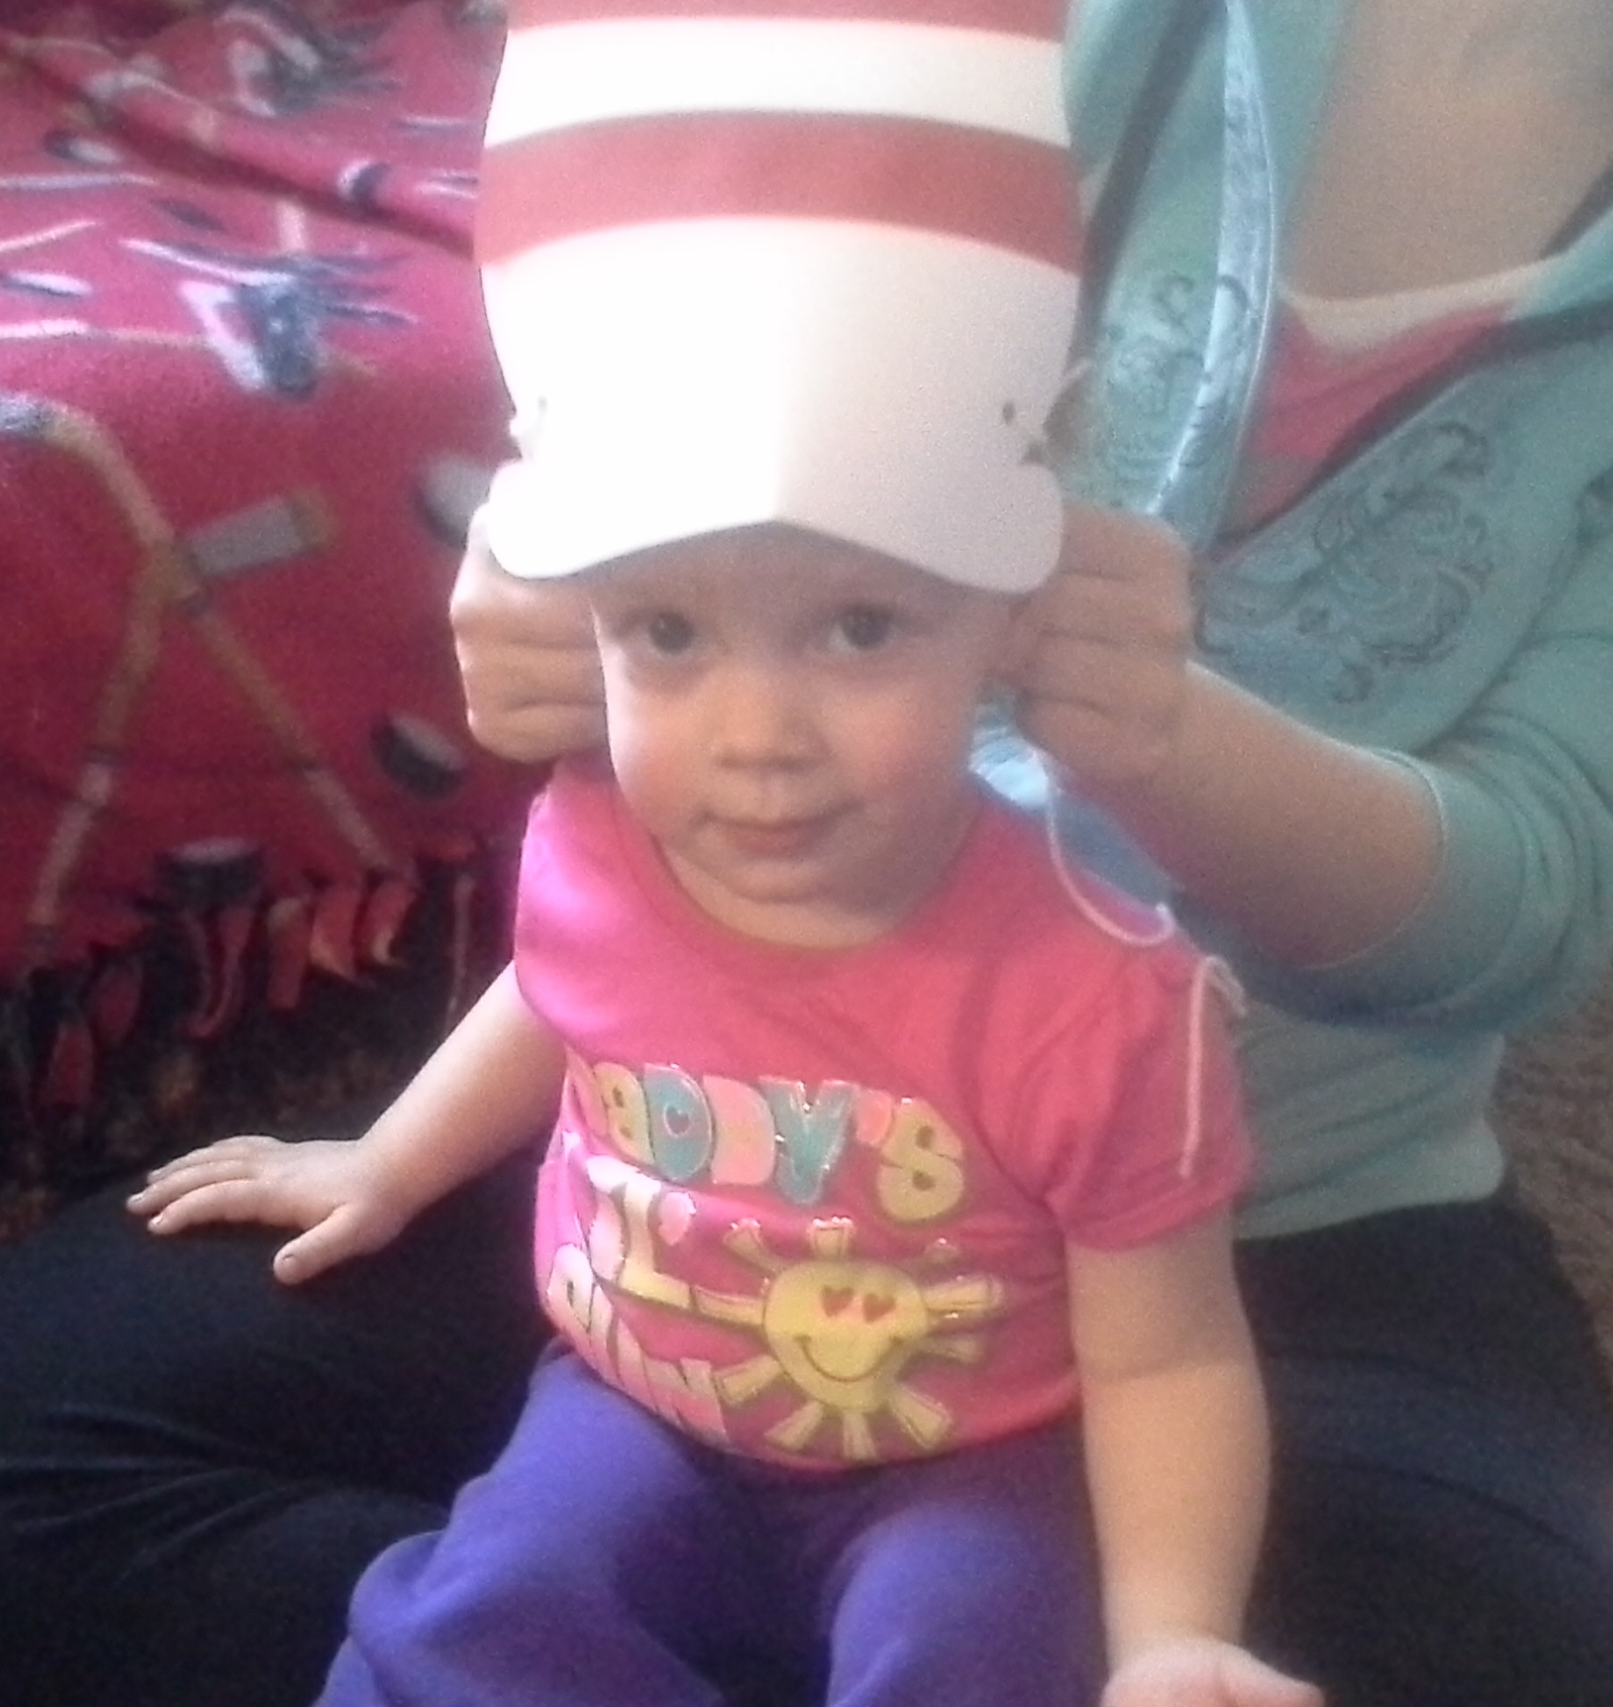
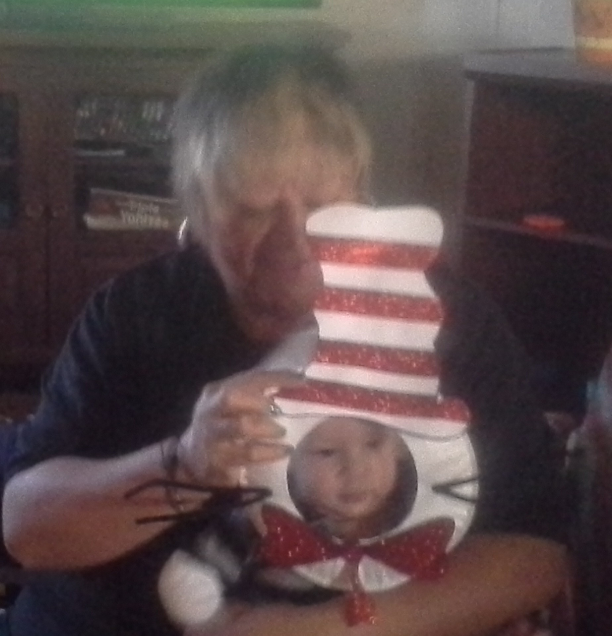
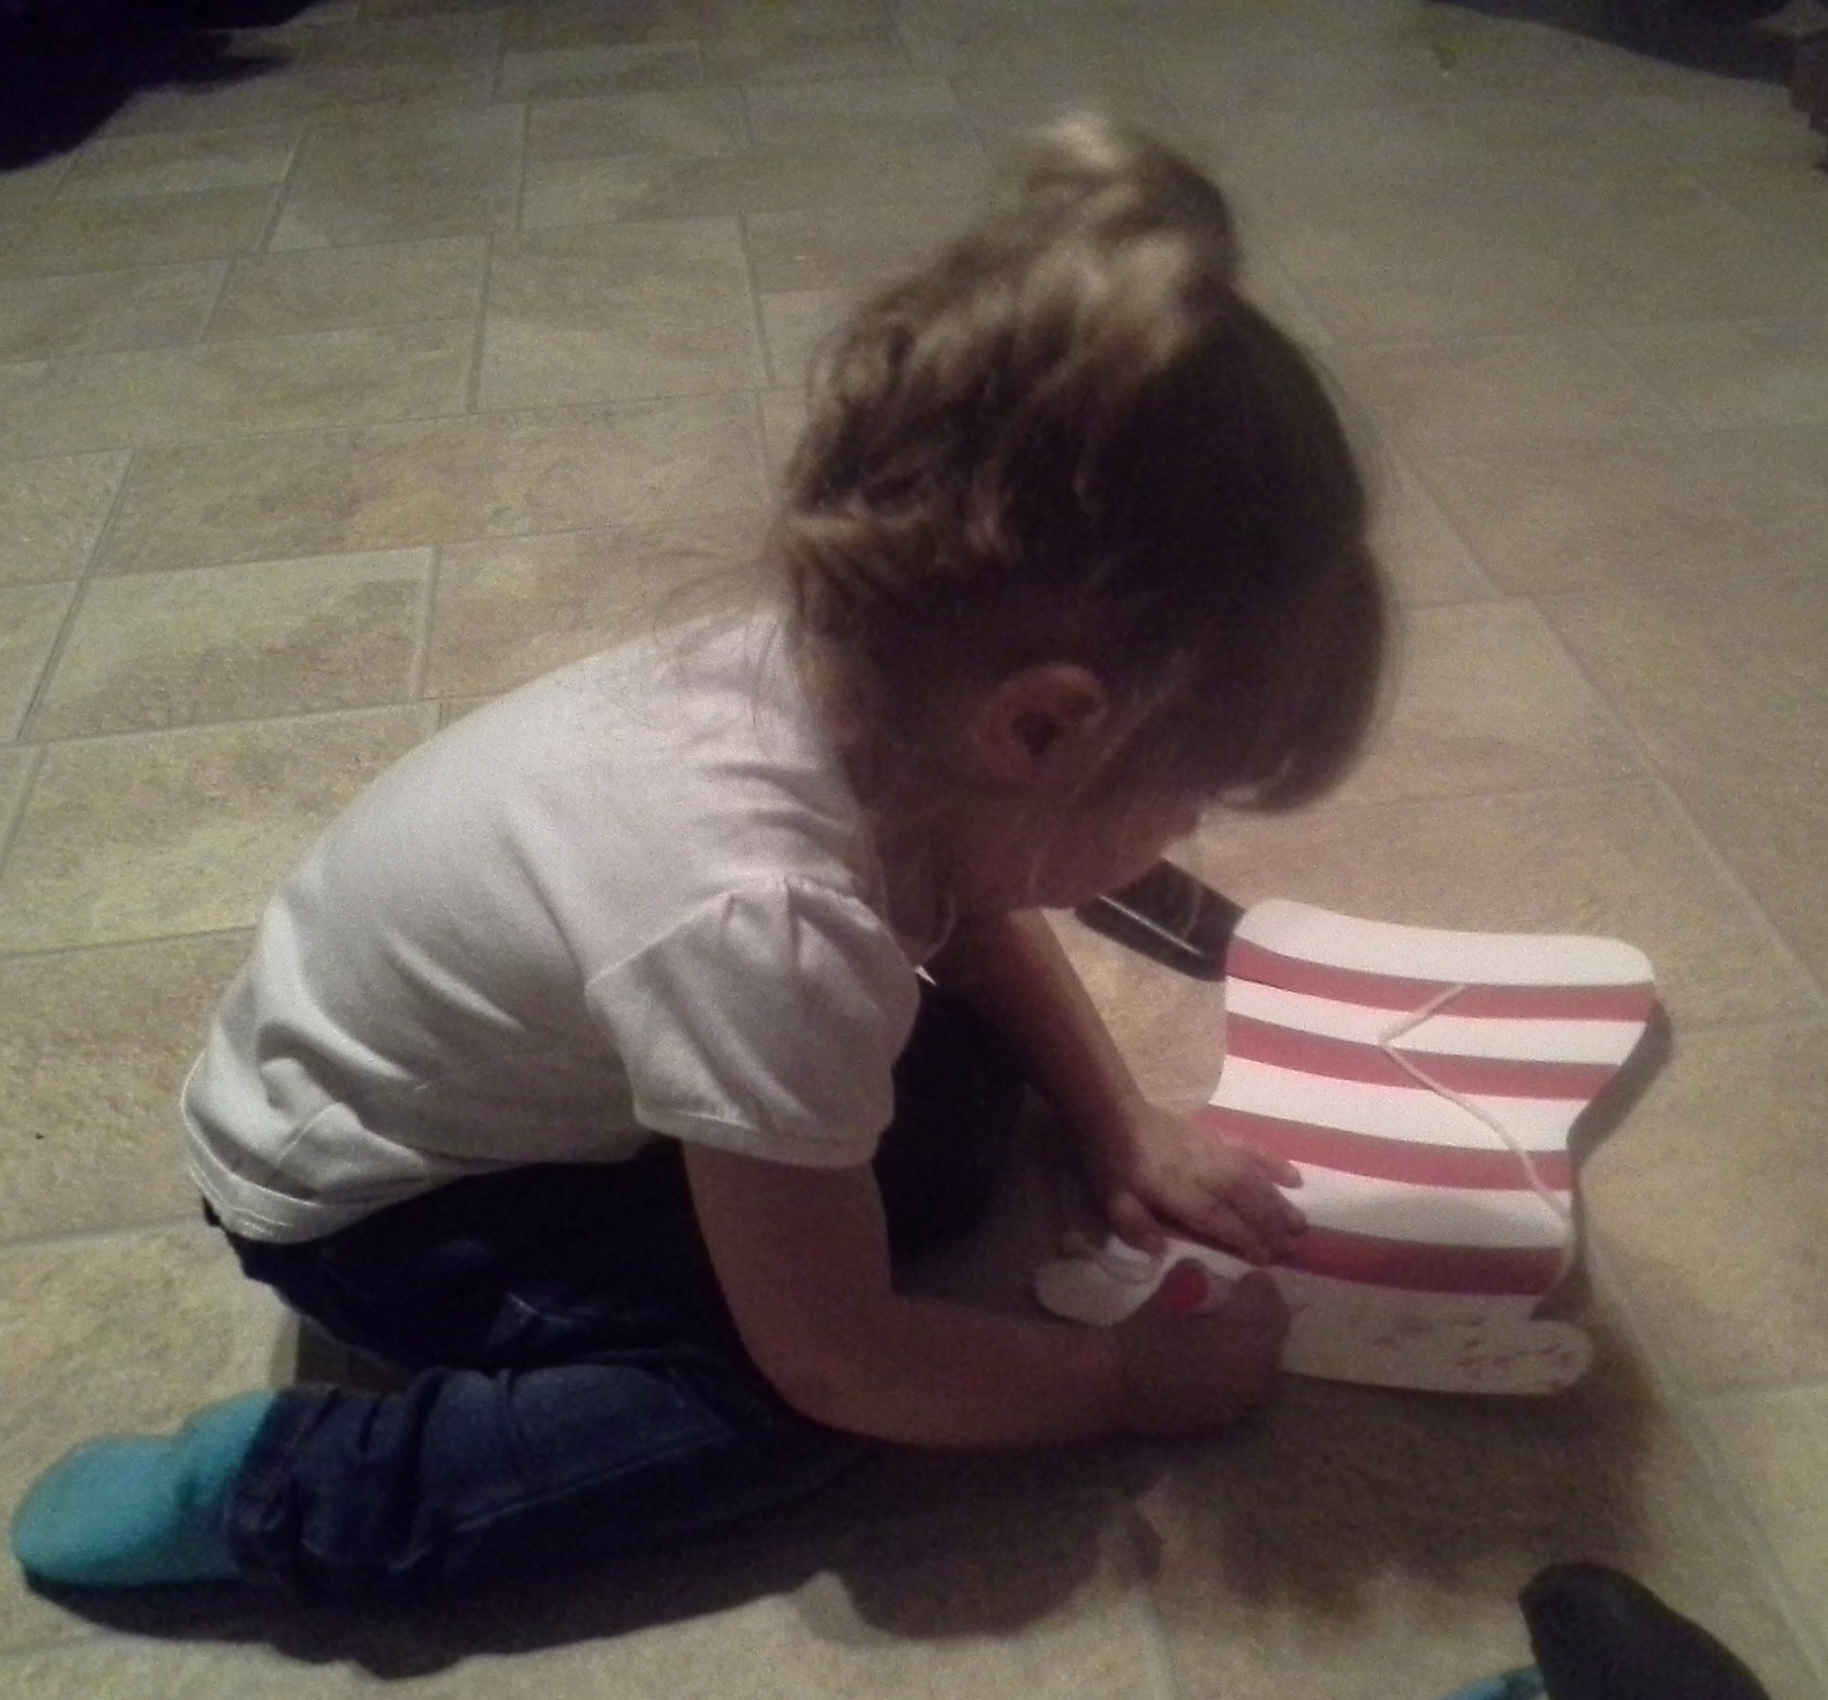


Summer Time!!! My favorite time of the year! So much to do, so much to see! We are very lucky that we live in such a very beautiful area. Sometimes we just need to stop and look around. Take a moment and see life through our children’s eyes. Spend some time taking walks, maybe a picnic, blow bubbles or play in the park. Here are two more outside activities you might enjoy:

Dinosaur Dig

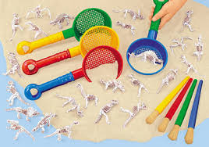
What you need:
Plastic dinosaur bones or small dinosaurs (any small plastic toy will work)
Shovels / paint brush
Sand or dirt
Some kind of container

Directions:
Place dirt or sand in the container and then bury the toys. Have the child dig up the bones or toys. Then you can look up and read about that dinosaur or object that your child found.

Hunting by Sounds
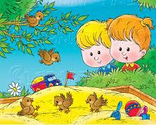
Talk to your child about different animal and bird sounds. Then go outside and sit under a tree. Have your child close their eyes and just listen. See how many different sounds you can hear. Try different locations and times of day. Have your child copy or describe the sounds they hear.

Enjoy the great outdoors and don’t forget the sunscreen and bug spray.

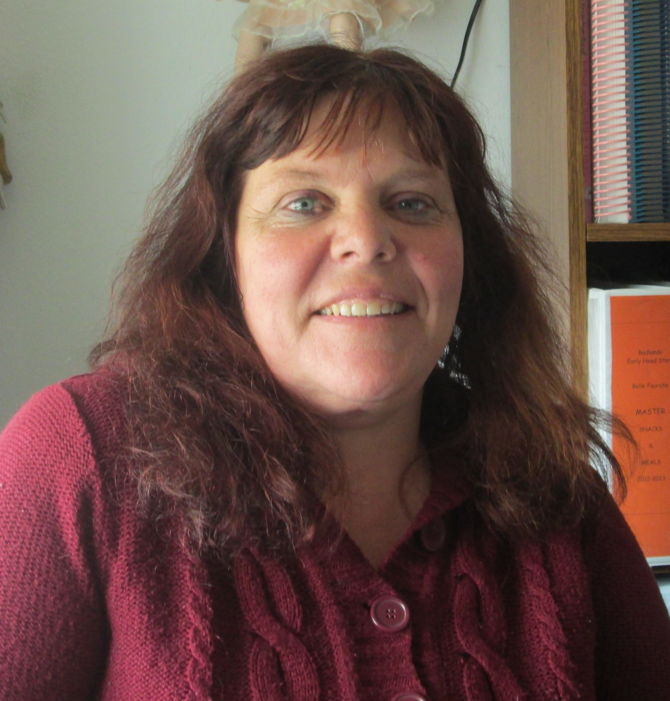
Michele Kreuzer-Ranken
Butte County ASM

Badlands Head Start: Prenatal to Five
Is currently taking applications for the 2016-17 School Year

Referrals from current and past Head Start families are one of the best resources we have for reaching out to new families. Please help us get the word out by informing anyone you may know that would qualify for our Head Start program in your area. Share with them the experiences and benefits of the Head Start Program and how they can contact us to obtain more information or to fill out an application.
Center Hours

Bison Center
Monday through Thursday
8:00 a.m.-12:30 p.m.

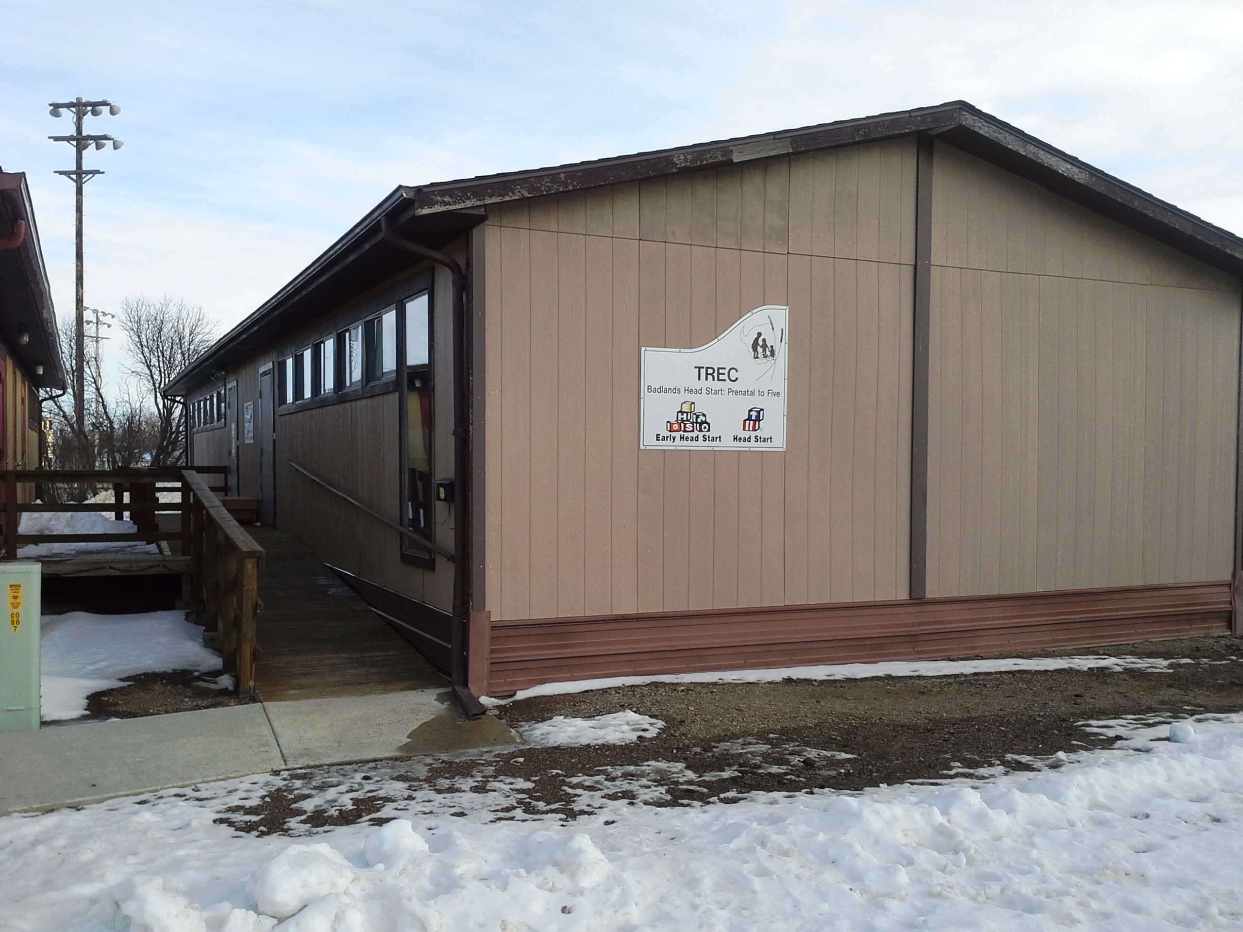
Lemmon Center
Monday through Thursday
8:00 a.m. – 2:00 p.m.

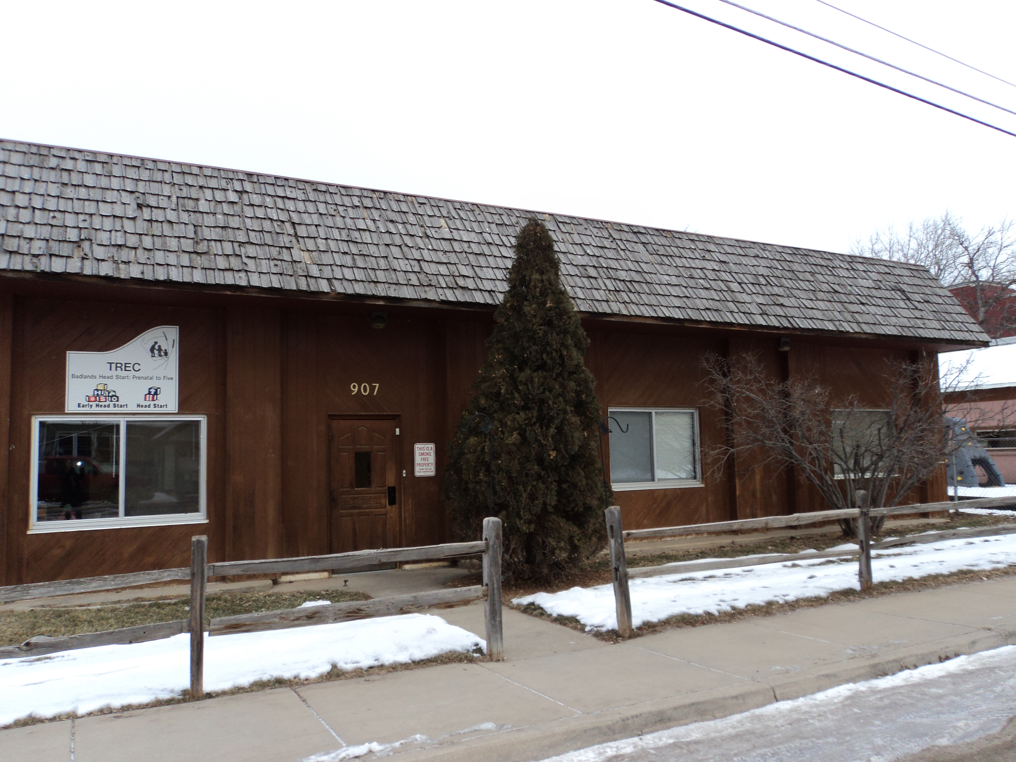
Belle Fourche Center
Monday through Thursday
8:00 a.m. – 2:00 p.m.

Butte County serves prenatal moms and children 0-3 years old. (Who do not turn 3 before Sept. 1st, 2016)
Harding and Perkins Counties serves prenatal moms and children 0-5 years old (who do not turn 5 before Sept. 1st, 2016)
Corson County, Oglala Lakota County and Bennett County serve children 3-5 years old (who do not turn 5 before Sept. 1st, 2016.

We work closely with school districts to provide for children with disabilities.

Reminder: When applying, please provide proof of income. We encourage families of all incomes to apply. Please give interested families the phone numbers to call the local offices or Belle Fourche office to fill out an application. Thank you!

Belle Fourche Office: 605-723-8837 or 800-598-5859
Bison Office: 605-244-5500 Buffalo Office: 605-375-3179
Kyle Office: 605-455-2799 Lemmon Office: 605-374-3134

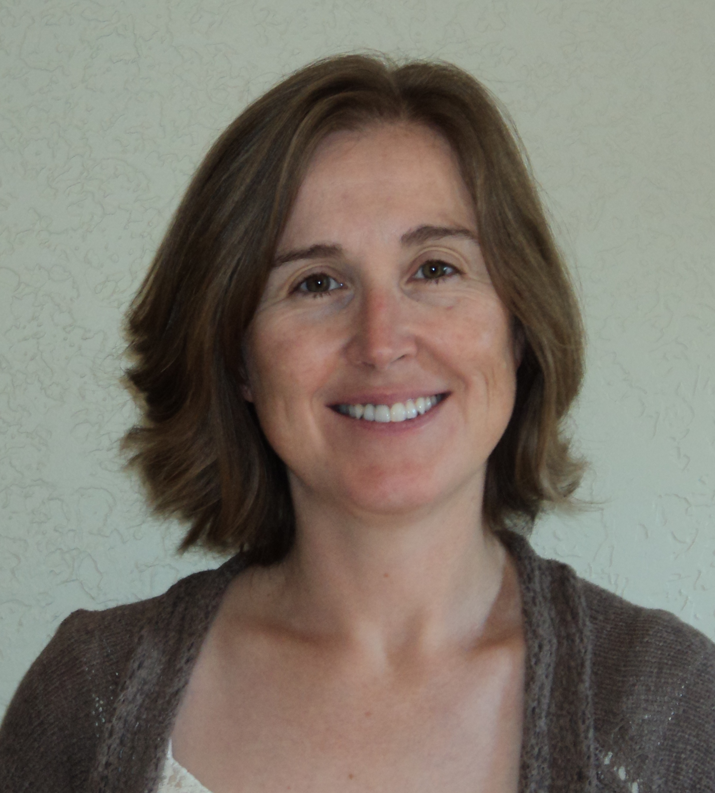

Young children learn about mathematical concepts early on, even as infants. Parents can support the development of these concepts throughout the day, including during every day routines. We’ve included some simple activities you and your child can do together to support your child’s understanding of mathematics.

Getting Dressed
While getting your child dressed ask the following questions:
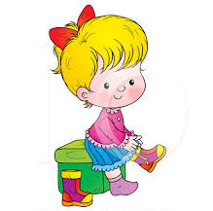
- “How many buttons do you have on your shirt? Let’s count them as I button you up.” This will help your child develop an understanding of numbers and one to one correspondence.
- “Here’s a sock for this foot. That’s one foot. Here’s a sock for the other foot. That’s two feet!” Your child will develop an understanding of numbers and one to one correspondence.
- “Do you want to wear your short pants or your long pants?” Your child will understand the concept of measurement and comparing sizes.

Setting the table
Have your toddler or preschooler help you set the table. Here are some questions you can ask your child:

- “Will you help me? Each person gets one fork, one spoon, and one napkin.” This will help your child with counting and using one to one correspondence.
- “How many spoons do we need? Let’s count.” Your child will learn to count as well as to solve problems.
- “What shape are the plates? What about the table?” Your child will learn about geometry and to recognize shapes.
- “Give the big cup to daddy. I would like to have a little cup.” Your child will learn about measuring items and comparing sizes.

For infants, you can describe to your baby how you are setting the table, giving each person a spoon, bowl, etc. By doing this, you are helping your baby become familiar with words associated with math and are modeling how math is used every day.

Eating a meal

There are many opportunities during meal times to help your child develop a better understanding of math concepts. The following questions and statements are examples of how to incorporate math into mealtime conversations with your child.
- “Your sandwich looks like a square. If I cut it this way (corner to corner), what shapes will it make?” Your child will learn about geometry and to recognize basic shapes.
- “How many pieces of cheese do you want” “Do you want one or two?” “Let’s count how many raisins you have.” Your child will learn about numbers and counting.
- “You have more pieces of apple than I do.” Your child will learn about numbers as well as how to compare the number of objects.

For infants, you can describe to your baby the shapes of the food, count the number of pieces they have to eat, etc. This will help your baby become familiar with mathematical terms.

Song and Finger play Corner
Counting songs and finger plays are also a great way to help your child learn to count. Here are some fun songs and finger plays for you and your child to do together. Enjoy!

Five Little Pigs
Five little pigs rolled in the mud,

Squishy, squashy, felt so good.
The farmer took one pig out.
Oink, Oink, Oink, the pig did shout.
Four little pigs rolled in the mud,
Squishy, squashy, felt so good.
The farmer took one pig out.
Oink, Oink, Oink, the pig did shout.
Three little pigs rolled in the mud,
Squishy, squashy, felt so good.
The farmer took one pig out.
Oink, Oink, Oink, the pig did shout.
Two little pigs rolled in the mud,
Squishy, squashy, felt so good.
The farmer took one pig out.
Oink, Oink, Oink, the pig did shout.
One little pigs rolled in the mud,
Squishy, squashy, felt so good.
The farmer took one pig out.
Oink, Oink, Oink, the pig did shout.
No little pigs rolled in the mud;
they all looked clean and good.
The farmer turned his back and then,
those pigs rolled in the mud again!

Five Little Ladybugs
Five little Ladybugs climbing up a door,
(Hold up 5 fingers)
One Flew away then there were four.
Four Little ladybugs sitting on a tree,
(Hold up 4 fingers)
One flew away then there were three.
Three little ladybugs landed on a shoe,
(Hold up 3 fingers)
One flew away and then there were two,
Two little ladybugs looking for some fun,
(Hold up 2 fingers)
One flew away and then there was one.
One little ladybug sitting in the sun,
(Hold up 1 finger)
She flew away and then there were none.

5 Enormous Dinosaurs
Five enormous dinosaurs letting out a roar,
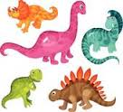
One went away and then there were four!
Four enormous dinosaurs munching on a tree,
One went away and then there were three!
Three enormous dinosaurs didn’t know what to do,
One went away and then there were two!
Two enormous dinosaurs having lots of fun,
One went away and then there was one!
One enormous dinosaur afraid to be a hero,
He went away and then there was ZERO

Submitted by: Melissa Pickle-Education Disabilities Specialist/Program Services Director

With only three weeks left of the school year for centers in Bison and Lemmon, staff has been busy completing projects and wrapping things up for the year.

Head Start home visitors will be done with services in early May in Buffalo and have helped prepare those going off to kindergarten with that transition. Julia Lermany has been subbing for Home Visitor, Jaylene Stirling, while she is home with her new baby boy Tayten. Thank you Julia for stepping in and continuing to afford families with the home visit experience! And congratulations to Jaylene!

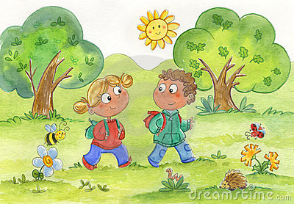
Early Head Start home visits will continue with weekly services throughout the summer and hopefully soon, the weather will cooperate so the kiddos and teacher can go outside and enjoy learning in nature. In Harding Co. the families have enjoyed two evening socials this spring, and continue to work on developmental milestones through various activities and learning experiences in the home.


Bison transitioning students got to enjoy Kindergarten roundup at the Bison school on April 21, 2016, with the other students joining them for lunch in the lunchroom and recess outside. Bison center is buzzing with readers now, as the older students have begun reading this spring and are pretty excited at their newly acquired skill! They have also been busy with several fun learning experiences such as watching their butterflies emerge while learning about their life cycle, and releasing them back into nature, trying out from alphabet yoga, spring planting, and learning to measure with Mr. Inchworm. Bison’s last social will be on May 9th with a rodeo theme.


Lemmon Center students have been busy with field trips to the nursing home where they made wind chimes and bird feeders with the residents, and had a special guest (a grandma) and her puppet “Spike” visit the center and teach the kids about healthy foods. The students have enjoyed working on pre-kindergarten skills through the use of several different mediums, and have enjoyed creative painting, mud soup, and shaving cream writing. The kids’ plants are growing nicely for their garden, and they have enjoyed digging for worms. They also attended Farm safety day and learned about staying safe.

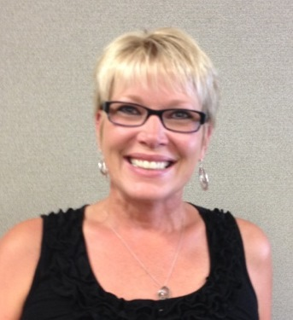
Ruth Adams
Area Services Manager
Harding, Perkins and Corson County

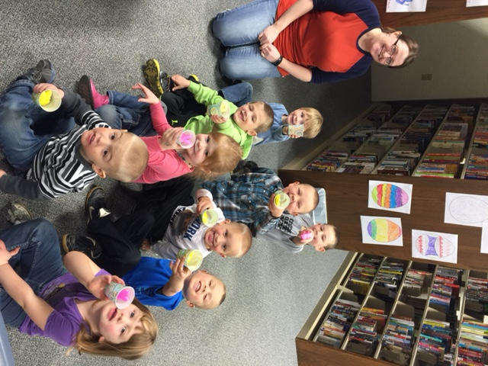
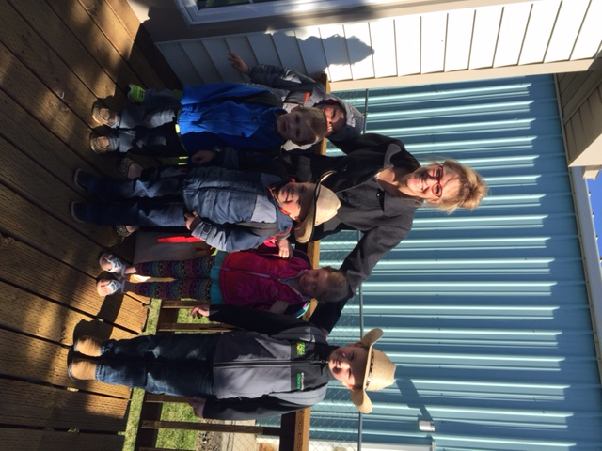

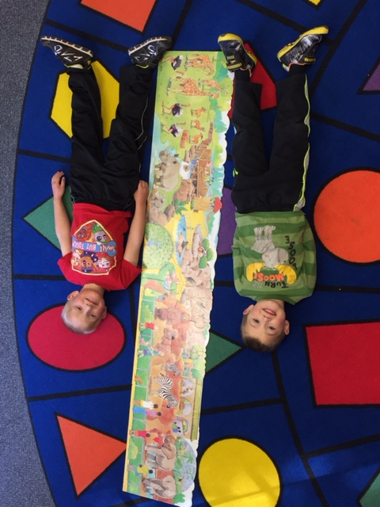
Ms. Julie and our “Future Kindergarteners” – Maverick K., James S., Albert K., Charlee V., and Owen S.
James S. and Zane C. measuring themselves next to a puzzle they put together.

Tori Voller, Student Volunteer, with Bison students: Albert K., Kimery S., and Greyson E.

The Bison Head Start class at the Public Library

