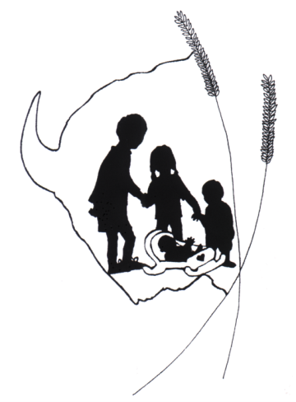

TREC: Badlands Head Start

Community Needs Assessment: 2014-15

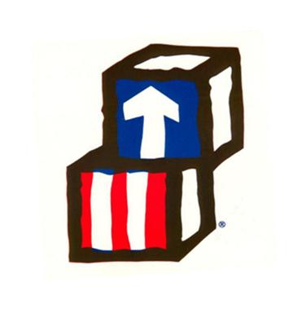

Contents
Introduction 4
Demographics of Head Start/Early Head Start Eligible Children & Families 5
Geographic makeup and overall population 5
Race/Ethnicity of TRec’s service area 6
Overall Population and estimated number of head start children 7
Community Growth 7
Area Employment Trends 8
Estimated Head Start/Early Head Start Population 9
Family Dynamics 10
Conclusions 10
Other Childcare providers serving TREC Children 11
Licensed Childcare Centers by County and Number Children Under Age 5 by County 13
Children with Disabilities and Services provided 14
Education, Health, Nutrition, and Social Service Needs 16
Education 16
Head Start/Early Head Start Assessments 16
Early Childhood’s Importance in K-12 (Preparation and Transition) 17
Nutrition 19
Health 20
Mental Health 24
Social Services 24
Conclusions 25
Community Resources (Partnerships) 26
Education 26
Students with Disabilities 27
Health and Dental Partners 27
Social Service Partners 29
Conclusions 29
profiles of individual counties 29
Bennett County 31
Butte County 33
Corson (Western) County 36
Harding County 39
Perkins County 42
Shannon County 45
Summary of key findings (overall) 48
Goals derived 48
Appendix A – Gold aggregation Data 49

Introduction
In order to properly align goals and aspirations of Head Start Agencies with community needs, the agencies must conduct community assessments to figure out, in an evidence-based manner, what the ‘real’ needs are for the communities they seek to serve. As it relates to Badlands Head Start, there are a variety of educational and community needs that were identified to best serve the communities in Western South Dakota.
Ultimately, data and information gathered through the Community Assessment process will inform the program goals and operations in the coming years. This is by no means a strategic plan, but it allows the agency to program and think strategically in the short-term.
In this document we shall cover many areas. First, the demographic and family dynamics of our estimated number of Head Start and Early Head Start children and families will be discussed. After discussing the people who make up TREC communities, we shall transition to topics related to community needs in regards to education, health, social services, child care, and community resources. Other items, such as employment trends and community growth will also receive attention in the assessment as they are important indicators related to community needs. Last, the assessment will take time to profile each of our counties and present data outlining critical success factors.
Children & Families

Demographics of Head Start/Early Head Start Eligible Children & Families
The first section of the Community Assessment for TREC – Badlands Head Start seeks to focus on the overall demographics of our service area. Demographics allow us to get a general gauge on the makeup of our families, tailor needs with regard to culture, and better understand certain needs or issues associated with the given populous.

Geographic makeup and overall population
As you can see from the map below, TREC – BHS covers a very expansive service area (figure 1.1). In fact, the TREC – BHS service area covers approximately 13, 500 square miles. Having a service area this large has some impact as it relates to travel and home-based services.
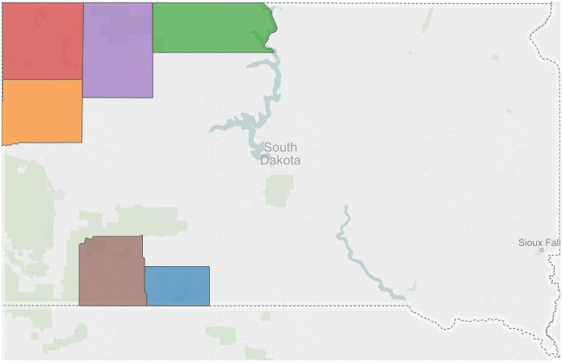
Butte
Harding
Perkins
Shannon
Corson
Bennett
Figure 1.1
The TREC administrative offices are located in the city of Belle Fourche. Belle Fourche is centrally located in the service area and has a population of approximately 5,700 people.
As we discuss the population and demographic indicators of the service area, it will become very clear as to the rural nature of the communities and families receiving services from TREC – BHS.

Race/Ethnicity of TRec’s service area
TREC serves a total of six counties (Bennett, Butte, Corson, Harding, Perkins, Shannon) in rural Western South Dakota. The service area tends to be geographically and culturally diverse. According to data obtained from the U.S. Census Bureau, TREC’s counties range from predominantly Caucasian in Butte, Harding, and Perkins to mostly American Indian in Corson, Bennett and Shannon counties. See figure 1.2 for clarification.
While these data are representative of the entire population, it tells us an important programmatic lesson. The makeup of our service area’s inhabitants is diverse. As a result, TREC – BHS must be conscious of these differences when it comes to tailoring our program around cultural and customary elements of the children and families.
Race/Ethnicity | Counties
 | Bennett | Butte | Corson | Harding | Perkins | Shannon
White alone, percent, 2013 (a) | 34.0% | 94.4% | 31.4% | 95.6% | 96.9% | 5.3%
Black or African American alone, percent, 2013 (a) | 0.4% | 0.8% | 0.2% | 0.6% | 0.3% | 0.2%
American Indian and Alaska Native alone, percent, 2013 (a) | 59.7% | 2.0% | 64.8% | 1.8% | 1.5% | 92.9%
Asian alone, percent, 2013 (a) | 0.7% | 0.3% | 0.3% | 0.2% | 0.3% | 0.1%
Native Hawaiian and Other Pacific Islander alone, percent, 2013 (a) | Z | 0.1% | 0.1% | 0.0% | 0.0% | Z
Two or More Races, percent, 2013 | 5.2% | 2.5% | 3.1% | 1.9% | 1.0% | 1.5%
Hispanic or Latino, percent, 2013 (b) | 3.3% | 3.5% | 3.8% | 2.5% | 1.1% | 3.0%
White alone, not Hispanic or Latino, percent, 2013 | 32.9% | 91.6% | 30.8% | 93.7% | 96.0% | 4.8%
Figure 1.2

Overall Population and estimated number of head start children

Community Growth
As we alluded to earlier, the TREC – BHS service area is large in terms of square miles, but it is also very rural in nature. In fact, the total population of the service area is estimated to be approximately 36,414 people. This equates to roughly 2.83 people per square mile.
Limited employment opportunities have hampered community growth in some of TREC’s service area. In fact, Harding and Bennett counties were quite stagnant. Because these communities are so rural, most opportunities for employment exist outside of their communities. This three year trend is evidenced below.
Conversely, Butte, Corson, and Shannon counties saw respectable growth numbers from 2010 – 2013. Geographically speaking, one could plausibly argue that because of abundant jobs in the North Dakota oil fields, the northernmost counties saw more growth.
Community Growth
Percent Population Change by County (2010 – 2013)
Bennett | Butte | Corson | Harding | Perkins | Shannon
0.6 | 2.2 | 4.1 | 0.6 | 1.8 | 3.9
Figure 1.3

Area Employment Trends
As it relates to employment within TREC’s service areas, most of the region has roots in the agricultural sectors. To be clear, farming and ranching are staples of life in the areas we operate. According to data obtained from the American Community Survey, aside from agriculture, Public Administration and Education seem to be the primary employment providers for those residing within TREC’s service area. These assumptions are validated by the data shown below. Individual communities and counties will be discussed at greater detail later in the assessment.

Employment by Industry
Industry | Bennett | Butte | Corson | Harding | Perkins | Shannon
Agriculture, forestry, fishing and hunting, and mining | 14.70% | 14.40% | 26.40% | 48.70% | 27.90% | 1.90%
Construction | 8.90% | 9.40% | 4.30% | 8.80% | 7.50% | 3.00%
Manufacturing | 2.10% | 5.70% | 1.00% | 0.10% | 8.60% | 0.50%
Wholesale trade | 1.70% | 0.80% | 1.60% | 0.60% | 2.30% | 0.20%
Retail trade | 8.30% | 14.30% | 8.40% | 9.20% | 8.40% | 7.00%
Transportation and warehousing, and utilities | 4.10% | 7.00% | 2.90% | 3.90% | 5.10% | 1.40%
Information | 2.10% | 0.50% | 2.50% | 0.70% | 1.00% | 0.00%
Finance and insurance, and real estate and rental and leasing | 6.60% | 3.10% | 2.90% | 2.00% | 2.40% | 2.90%
Professional, scientific, and management, and administrative and waste management services | 1.40% | 4.40% | 1.60% | 1.60% | 3.60% | 2.30%
Educational services, and health care and social assistance | 29.20% | 19.70% | 24.30% | 11.60% | 20.90% | 44.90%
Arts, entertainment, and recreation, and accommodation and food services | 5.70% | 9.50% | 9.60% | 6.60% | 2.90% | 12.80%
Other services, except public administration | 2.30% | 5.80% | 3.10% | 1.60% | 5.40% | 3.50%
Public administration | 12.90% | 5.30% | 11.40% | 4.50% | 4.20% | 19.80%
Figure 1.4
The data are helpful in determining where people are employed, but they leave out some important contextual and economic factors that describe our communities. Populations in most communities where TREC offers programming are very small. Therefore, employment is often very limited in some cases. In addition, with little or stagnant community growth, economic development is stymied and prevents additional industries and corporations from entering the more rural communities.

Estimated Head Start/Early Head Start Population
When it comes to the estimated number of Head Start and Early Head Start children, TREC utilized data from both the American Community Survey and the U.S. Census to estimate the number of children receiving Head Start and Early Head Start services. The poverty indicator was used because the reliability of other data were subject to large degrees of skepticism. To be clear, although other indicators (e.g., SNAP/TANF recipients) do hold some value, they are not stringent enough to determine Head Start or Early Head Start eligibility. The table below shows the estimated number of children by county.
Estimated Number of HS/EHS Eligible Children
Bennett | Butte | Corson | Harding | Perkins | Shannon
217 | 91 | 198 | 14 | 20 | 1102
Figure 1.5
When looking at Shannon County, it seems that there is ample opportunity to recruit and maintain children and families for Head Start purposes. That number is misleading a there are other programs that provide similar services to low-income families. Specifically, there is another Head Start organization in Shannon County that also serves children from the same population base. Each organization is helping to serve an area that has a great number of people requiring our services.

Family Dynamics
When providing services to families within the TREC boundaries, it is important to consider the dynamics of past families we have traditionally served. The Program Information Report (PIR) gives us valuable insight as to how our families are made up, and the data can help to drive our programing needs. In this section, we will discuss topics ranging from single parent families, levels of education, and homelessness. These and other topics will be covered to better understand how we can work with families in the future.
According to PIR data in 2104, 43.86% (95) of TREC families are comprised of a single parent. Traditionally, the likelihood of single parent families finding themselves in poverty has been much higher than two parent families. The absence of support and an additional income help explain this claim. In addition, poverty or income loss impacts parenting in an adverse way. For example, a significant loss of income and lack of subsidies adds additional social and emotional stressors to an already delicate dynamic.
In addition to the high number of single parent families, education plays a role in what the family can achieve from a pedagogical and employment standpoint. Most parents of children in our program have a high school diploma or GED. While this is promising, the PIR also illustrates that 49 parents of Head Start and Early Head Start programs possess less than a high school diploma (or equivalent). Although this is only one year of data, it makes an important point in terms of programming and training parents. Research has shown strong correlations between level of education and earnings capacity. If we are truly partners, something must be done to encourage and develop the parents of Head Start and Early Head Start children.

Conclusions
As mentioned before, demographics of our service area plan an important part in how we plan and design our program operations. It is increasingly clear from the information presented above that a number of program options must be employed to meet the needs of children and families within the six counties. Both center and home-based head start options are appropriate for our service areas. The more rural areas may benefit greatly from the home-based Head Start and Early Head Start option; whereas, regions with a higher population base (e.g., Belle Fourche, Bison and Lemmon) might have more success with a center-based approach to services (with expanded home visits).
Race and ethnicity in our region helps us plan and tailor our program approach to the needs of each individual and their respective culture. As you can see, there is a need to plan for approaches that are sensitive to both the Anglo-Saxon (Caucasian) and Native American cultures. It is imperative that we respect each culture and incorporate traditions and norms to build relationships.
Family dynamics also help us plan around the needs of our families. We spoke about the estimated number of children eligible for services and find that there is a great need for Head Start and Early Head Start services in each of the counties we serve. Increasingly, Butte County is becoming a center that could see expansion. In addition, the composition of our families helps us define the services we need to provide and referrals for other programs that can be made to help families live with more stability.
In reflection, there is a definite need for a variety of program options in our communities. Also, the services provided and lessons taught need to be culturally diverse and pay respect to the individuals that embrace the mentioned cultures. Last, family composition ( dynamics) give us valuable information when it comes to making referrals for additional family services. In other words, it spells out a path for utilizing our community partners to fulfill that health, medical, and social service needs that Head Start may not be able to fill.

Other Childcare providers serving TREC Children
Documenting and understanding the presence of other child care providers in the service area is important to understanding the need of additional child care operations to serve the children in communities where TREC is operational. Data were obtained as a result of a survey conducted during the 2013-14 school year. Additional data are unavailable at this time.
In addition to the Local Education Agencies (LEAs) and Non-Profits who serve children in the TREC region, there are also licensed child care providers who offer varying levels of services to children and families. The services range from child care to actually conducting preschool lessons. The following is a list of other programs within the Badlands Head Start: Prenatal to Five service area that also provide services to Early Head Start & Head Start children
Entity Name | City/County | Number of Children | Services Provided
Bennett County Schools District Preschool | Martin | 20 | Center-based preschool serving 4 year olds
Bennett & Jackson County Public Schools Birth to Three Programs | N/A | 17 | Serves Birth to 3 Special Education students and provides home-based services
Birth to 3 Connections | Butte County | 16 | Serves Birth to 3 Special Education students and provides home-based services
Bison and Lemmon Public Schools | Bison and Lemmon | 8 | Serve children with disabilities/special needs from birth through 5.  Provides disability/special needs services in the home
Kadoka School District Special Education Program | Kadoka and Potato Creek | 56 | Serves children ages 0 – 5 with special education needs.  Their home based services extend to Potato Creek area in Shannon County.
Little Wound School FACE Program | Shannon County | 65 | Family literacy program working through preschools and home visits.
Newell School District Preschool | Butte County | 22 | Center based services to 4 year olds with disabilities/special needs.
NW Area Birth to 3 Connections | Conson/Perkins County | 2 | Serves children with disabilities/special needs birth through 3.  Provides disability/special needs services in the home.
Oglala Lakota College Head Start | Shannon County, Bennett County, Jackson County | 591 | Center based (31) Head Start programs serving the Pine Ridge Reservation.
Oglala Lakota College Early Head Start | Shannon/Jackson County | 100 | OLC-EHS serves Pine Ridge Reservation children birth to 3 in center-based services.
Oglala Sioux Tribe Childcare Program | Shannon/Jackson County | 180 (maximum) | Serves children ages 0 – 11 in a childcare setting.
Parents as Teachers | Butte County | 40 | Monthly home visits with parents.  Limited parenting and preschool classes.
Shannon County Schools Birth to Three and Preschool | Shannon County | 95 | Center based preschool at all of their schools except Red Shirt.  Also serve birth to three children with disabilities/special needs - home based.
Standing Rock Sioux Tribe | Corson County | 332 | Home and center based Early Head Start and Head Start programs.
Figure 2.1

Licensed Childcare Centers by County and Number Children Under Age 5 by County
Child care centers play an important role in developing social traits and skills among children. TREC’s service area seems to have an adequate number of registered and licensed child care facilities for family use in most areas. However, in communities such as Bison (Perkins County), there is a severe shortage of high quality and affordable child care. In communities where child care is not a problem, the quality and affordability of these entities is subject to some investigation.
At this time, South Dakota does not offer public funding for our pre-kindergarten preschool centers. Therefore, no uniform standards have been put in place to assess the quality of programming in these facilities. The South Dakota Early Learning Guidelines are a good start, but are not substitute for formalized, well researched, and pressure-tested content and developmental standards.
In addition, the financial implications on families receiving child care is something we need to examine and consider. There is no uniform rate for child care in South Dakota. Therefore, families are at the mercy of the provider when it comes to a payment schedule. There are programs available to help families pay for child care, but the rate of reimbursement may not lend itself to enroll a child in a quality program. Families should not be forced to choose between quality and affordability.
County | Licensed  Group Family  Child Care Homes  (Max = 20) | Registered  Family  Child Care Homes  (Max. = 12) | Licensed  Child Care Centers  (Max. = 21+) | Maximum Number  Children Served | Number  Children  Under Age 5  (2013) | Number  Under Age 5  In Poverty  (2013)
Corson | 0 | 1 | 0 | 12 | 366 | 179
Perkins | 1 | 1 | 0 | 32 | 157 | 18
Harding | 0 | 1 | 0 | 12 | 89 | 12
Butte | 2 | 10 | 1 | 181+ | 661 | 82
Shannon | 4 | 2 | 0 | 104 | 1,637 | 1002
Bennett | 1 | 4 | 0 | 68 | 352 | 197
Figure 2.2
In sum, although there are an ample number of child care entities serving the counties where TREC provides Head Start and Early Head Start programs, it is unknown as to the relative quality and affordability that these programs give their children and families. This will require further investigation, planning, and study.

Children with Disabilities and Services provided
Children with disabilities are an important part of the population TREC serves. Unlike regular education students, children with disabilities require a special amount of care that often requires a specialized form of instruction, physical, and developmental services. While TREC does partner with many agencies to help with services (physical, counseling, etc.) for students with disabilities, we aim to meet the most essential needs of the child.
Determining the number of Students with Disabilities under the age of 5 years is key to planning for services within our counties. The table below illustrates the estimated number of Students with Disabilities in the counties which TREC serves. We determined the number of Students with disabilities in our counties by multiplying the PK-12 Special Education percentage by the number of children less than 5 years of age in each county. Head Start Performance Standards indicate that at least 10% of enrolled students must be students with disabilities. It is evident from the data that we can certainly fulfill these requirements if we are painstaking about our recruitment efforts. In addition, the data below are very helpful when it comes to deciding what program options work best in certain counties. It is clear from the data that a combination of home-based services and center-based services are necessary to fulfill the needs of our communities. Data from the Program Information Report (PIR) helps bring detail to light in terms of Students with Disabilities enrolled in Head Start and Early Head Start. This information is highlighted in the paragraphs below.
County | # Special Education Under 5
Bennett | 46
Butte | 106
Corson | 20
Harding | 12
Perkins | 20
Shannon | 356
Figure 2.3
According to Program Information Report (PIR) data from the 2013-2014 year, TREC had approximately 29 children enrolled in our programs that were either on an Individualized Education Program or Individual Family Service Plan. When you break it down by Head Start and Early Head Start, this equates to approximately 10% of Head Start and 15% of Early Head Start children receiving Special Education services. More often than not, Head Start children receiving services were categorized as needing help with speech and language. A smaller number of students received services relating to developmental delays.
Due to our size, TREC could not provide all services for Students with Disabilities on its own. Therefore, we rely heavily on many community partners to help facilitate the work. We discuss the partners in a more detailed fashion later in this assessment, but Birth to 3 Connections and many LEAs (e.g., Bison, Harding County, Belle Fourche, Newell, Lemmon, and Shannon County) provide much help with our Special Education population.
Data from the South Dakota DOE illustrate that approximately x% of the school age population in our counties have disabilities. These data are helpful as they let us know how the PreK-12 numbers stack up in terms of Special Education students. In addition, these percentages were actually used to derive the estimated number of Head Start and Early Head Start eligible children who would potentially need Special Education services. This is explained in detail above.
District Name | Total Special Education | % of PK-12 Students
Belle Fourche 09-1 | 205 | 15.19%
Bennett County 03-1 | 66 | 13.20%
Bison 52-1 | 19 | 12.84%
Harding County 31-1 | 23 | 12.85%
Lemmon 52-4 | 34 | 12.78%
Newell 09-2 | 63 | 18.21%
Shannon County 65-1 | 318 | 21.72%
Figure 2.4

Education, Health, Nutrition, and Social Service Needs

Education
Education is an important piece of the holistic programming offered by TREC – Badlands Head Start. A sound education for children in our service area will prepare them for success later on in life. In addition, quality education programming as a result of Head Start attendance can better prepare our children for the successful transition into the K-12 education world. Currently, Head Start and Early Head Start programs offer a well-rounded curriculum to develop the whole child as well as empower the families in a variety of ways. This section shall focus on how TREC develops our children and families, strengths in program areas, and work that needs to be done.

Head Start/Early Head Start Assessments
TREC – Badlands Head Start utilizes the Teaching Strategies GOLD platform to conduct educational assessments on our students. The data has proven to be invaluable when considering individualization, setting program goals, and ensuring that we are meeting goals set for school readiness. This year was no exception. Mathematics and Literacy are constant areas of focus. Children need a solid foundation when it comes to these subject areas. As we analyzed the GOLD data at a program level, some patterns started to emerge in the data. TS GOLD aggregation data is available for viewing in Appendix A
First, for the vast majority of ‘widely held expectations’ the children at TREC – BHS are meeting expectations. However, they are meeting expectations in the lower quartiles. In addition, for 1 to 2 year olds, TREC – BHS did not meet expectations. The data from TS GOLD tell us a few important things. First, although we meet expectations in many of the categories listed (e.g., social emotional, language, etc.) there is significant room to grow. In addition to growing as a program, the overall trend in the GOLD data is that curricular standards as a whole need careful attention and strengthening. Third, the data for 1 – 2 year olds not meeting expectations is especially troubling. TREC must focus on the individual students and prepare them for successful transition into the Head Start classroom or home-based setting. This can be done by individualizing lessons for our children and families.
It is also important to recognize the role of the parent in these activities. Education, often times, starts in the home with a parent as the primary instructor of the child. Simple and meaningful activities can be used in the home to bring children up to speed.
All in all, TREC’s data show we are not missing the boat in terms of educating the children we serve. However, it is abundantly clear that we can and will do a better job in the future. When one digs deeper into the data, the notion of individualization becomes that much more important. In fact, as a program students in every age group had some deficient students in every category (e.g., Social Emotional, Physical, Cognitive, Language, Literary, and Mathematics). Simply put, there is more growth that can be attained.

Early Childhood’s Importance in K-12 (Preparation and Transition)
Bridging the gap from Early Childhood to the K-12 environment, emphasis on the aforementioned skills becomes paramount in terms of relative importance. We shall highlight below, by using K-12 assessment data, how important our impact on learners in Early Childhood really is.
Taking a look at the data below, students taking the third grade assessment did fairly well in the areas of Reading and Mathematics. There are, however, a number of students in TREC’s service are who are not meeting proficiency levels in the aforementioned subject areas. While a student should not be judged solely on the basis of one summative assessment, it is imperative to consider these data as they are telling of transition efforts and preparation. This makes our job in Early Childhood even more critical.
Various research studies have shown that proficiency in key areas of learning (e.g., reading and math) during early grades is paramount to success further on in a student’s academic career. Assessment data aside from 3rd grade Reading and Mathematics proficiency is unavailable at the current time.
2012 – 2013 Accountability Results
District Name | School Name | Grade | Subject | Adv | Prof | Basic | Below Basic
Bennett County | Martin Elem | 3 | Reading | 22% | 46% | 32% | 0%
Bennett County | Martin Elem | 3 | Math | 12% | 59% | 29% | 0%
Belle Fourche | South Park Elem | 3 | Reading | 22% | 50% | 28% | 0%
Belle Fourche | South Park Elem | 3 | Math | 13% | 59% | 28% | 0%
Harding County | Buffalo Elem | 3 | Reading | . | . | . | .
Harding County | Buffalo Elem | 3 | Math | . | . | . | .
Harding County | Camp Crook Elem | 3 | Reading | . | . | . | .
Harding County | Camp Crook Elem | 3 | Math | . | . | . | .
Bison | Bison Elem | 3 | Reading | 27% | 36% | 36% | 0%
Bison | Bison Elem | 3 | Math | 0% | 64% | 36% | 0%
Lemmon | Lemmon Elem | 3 | Reading | . | . | . | .
Lemmon | Lemmon Elem | 3 | Math | . | . | . | .
Newell | Newell Elem | 3 | Reading | 35% | 55% | 10% | 0%
Newell | Newell Elem | 3 | Math | 20% | 60% | 20% | 0%
Shannon County | Batesland Elem | 3 | Reading | 0% | 42% | 58% | 0%
Shannon County | Batesland Elem | 3 | Math | 0% | 16% | 84% | 0%
Shannon County | Wolf Creek Lower Elem | 3 | Reading | 0% | 25% | 71% | 4%
Shannon County | Wolf Creek Lower Elem | 3 | Math | 0% | 15% | 83% | 2%
Shannon County | Rockyford Lower Elem | 3 | Reading | 0% | 30% | 67% | 3%
Shannon County | Rockyford Lower Elem | 3 | Math | 0% | 27% | 70% | 3%
Shannon County | Red Shirt Table Elem | 3 | Reading | . | . | . | .
Shannon County | Red Shirt Table Elem | 3 | Math | . | . | . | .
Figure 3.1
TREC’s focus on delivering rigorous and quality programming is more important than ever. In the age of high profile testing and new content standards, it is likely that K-12 test scores and proficiency percentages will fall significantly in the 2014-2015 school year.
As a result of the aforementioned, TREC will have to be very focused on providing rigorous and valuable programming in all areas. Like most years, an emphasis in mathematics and literacy will be paramount as they are the building blocks of learning. In addition, a heavy amount of attention will be placed in the area of Social Emotional development. Learning math and literacy is incumbent upon a child being able to control their behaviors and emotions in a classroom setting.

Nutrition
Health and nutritional needs for children are the foundation of a successful learning experience in the classroom. In addition, a healthy mind and body are essential to a child’s longevity and overall quality of life. TREC firmly believes in taking care of the children’s health and nutritional needs by providing services directly related to the well-being of each individual served. This section seeks to explain and understand the positive things happening in each of the communities as well as highlight some areas where we can improve our mission of helping communities recognize the importance of health and nutrition in the family.
Childhood obesity is a fairly common concern among health and nutrition professionals in South Dakota. In fact, the data published by the Department of Health (DOH) and Department of Education (DOE) point out that, as a state, 28.7% of children ages 5 -8 in the sample were either overweight or obese (South Dakota Department of Health, 2014). That is nearly one third of the sampling fall into either the obese or overweight category. While this is the case representative in South Dakota, a closer examination of TREC’s service area is warranted to determine the health and nutritional needs of our communities.
The data below illustrate a comprehensive picture of Head Start children in all counties which TREC serves. It is clear from the data that many students our counties not suffering the effects of childhood obesity. In fact, the data tell us that in every county there are a number of children that fall into either the overweight or obese category. One could plausibly argue that the children are receiving the nourishment and amount of food necessary, but they may be indulging in the wrong kinds of foods. Building on this information, exercise becomes an important factor in combatting obesity.
Head Start BMI by Counties (clustered)
BMI Category | Bennett/Shannon | Butte | Corson/Perkins | Harding | Totals
Underweight | 2 | 5 | 2 | 0 | 7
Normal | 31 | 44 | 19 | 4 | 98
Overweight | 3 | 12 | 6 | 3 | 24
Obese | 7 | 9 | 3 | 1 | 20
Figure 3.2
It is part of TREC’s mission to give the children in our area the most ample opportunities to be healthy and successful. After all, nutritional needs being satisfied are part of a healthy lifestyle. Bringing a healthy child to the classroom impacts their ability to be successful academically.
Data from the BMI can only help us to an extent, and they do not paint a picture of trends developing in terms of long-term nutrition considerations for TREC children and families. In fact, past data point out that this observation is somewhat cyclical. To be clear, weight patterns vary regularly and by cohort. Also, this is only part of the picture. Plentiful and nutritious food are certainly part of the overall equation, but proper hygiene habits and preventative healthcare also ensure that TREC’s children are in the best position possible to learn and develop. We shall discuss this next.

Health
In the section above, we talked at length about the nutritional needs and education. In order to be successful in either of the aforementioned, children must be willing to enter the program healthy. A healthy body is the basis for successes in other areas of TREC’s program.
TREC currently assesses each child entering the Head Start and Early Head Start programs according to the guidelines espoused under the Head Start Act and under Head Start Performance Standards. The findings in the data are telling in many ways. First, TREC’s children are generally healthy overall. A general look at the Program Information Report (PIR) data serves to confirm this assumption. There are, however, some areas where TREC students enter the program with health deficiencies. The data below, in regards to vision, seem to indicate that vision is a specific problem in Shannon and Bennett counties. In addition, a fair percentage of children in Butte County possess vision deficiencies as well. The other counties (Perkins, Corson, and Harding) did not have the same problems with vision that those in Butte, Shannon, and Bennett counties did.
Dental screenings are part and parcel of our programming. While the Head Start and Early Head Start screenings tell us the potential problems in regards to dental health, they are not entirely focused in the solution. In fact, the data from our Program Information Report (PIR), shows a good number of Head Start children require follow-up dental treatment. Many children are receiving preventative care prior to enrolling in the Head Start program. However, more than half of the children need follow up treatments, and some require serious oral surgeries to repair dental problems. The implications of poor oral health on a child is significant and can be life-threatening is some cases. It is clear that TREC must focus on both the dental screenings for children as well as educating families about the importance of everyday dental hygiene.
Prenatal health and overall checkups are integral to a child’s health. From a program perspective, the PIR data illustrate a lack of enrollment in Early Head Start programs during the first trimester of pregnancy. The longitudinal history of low enrollment in the first trimester indicates this is a trend for TREC programs. These statistics are a little unsettling. The data do offer some solace, though. More women are enrolling in the second and third trimester in order to receive the prenatal services and education important to their child’s well-being.
Enrollment Period | Number | Percentage
Enrolled During 1st Trimester | 4 | 26.67%
Enrolled During 2nd Trimester | 4 | 26.67%
Enrolled During 3rd Trimester | 7 | 46.67%
Medically High Risk Pregnancies | 9 | 60.00%
Figure 3.3
One cannot fully assess the health of our children without also looking at the availability of healthcare providers in the communities we serve. Being in a rural and somewhat isolated area, medical and dental services can be somewhat hard to find – as evidenced by the graphics below.
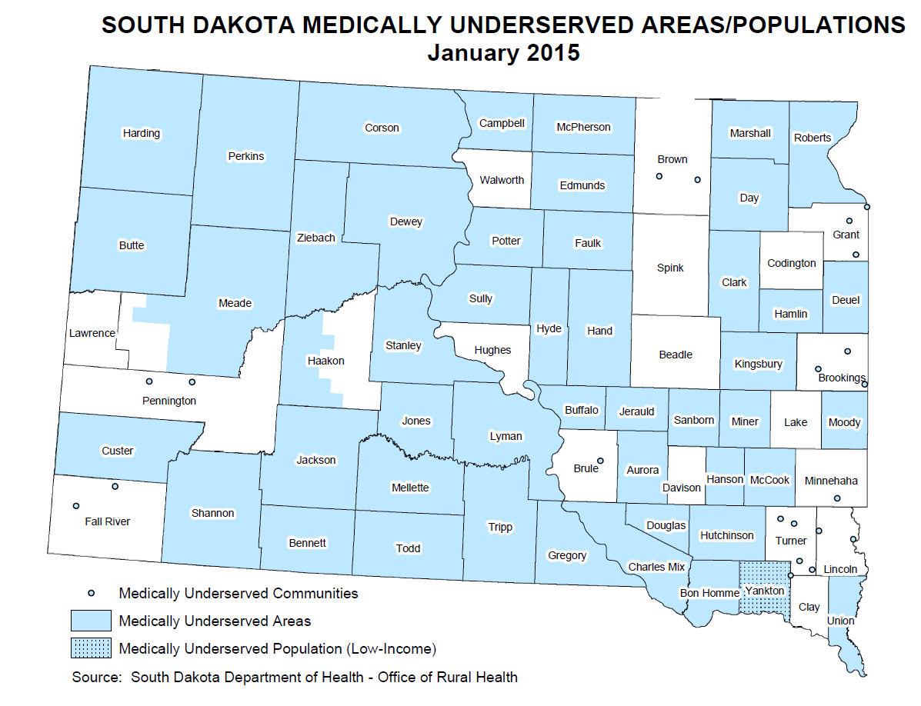

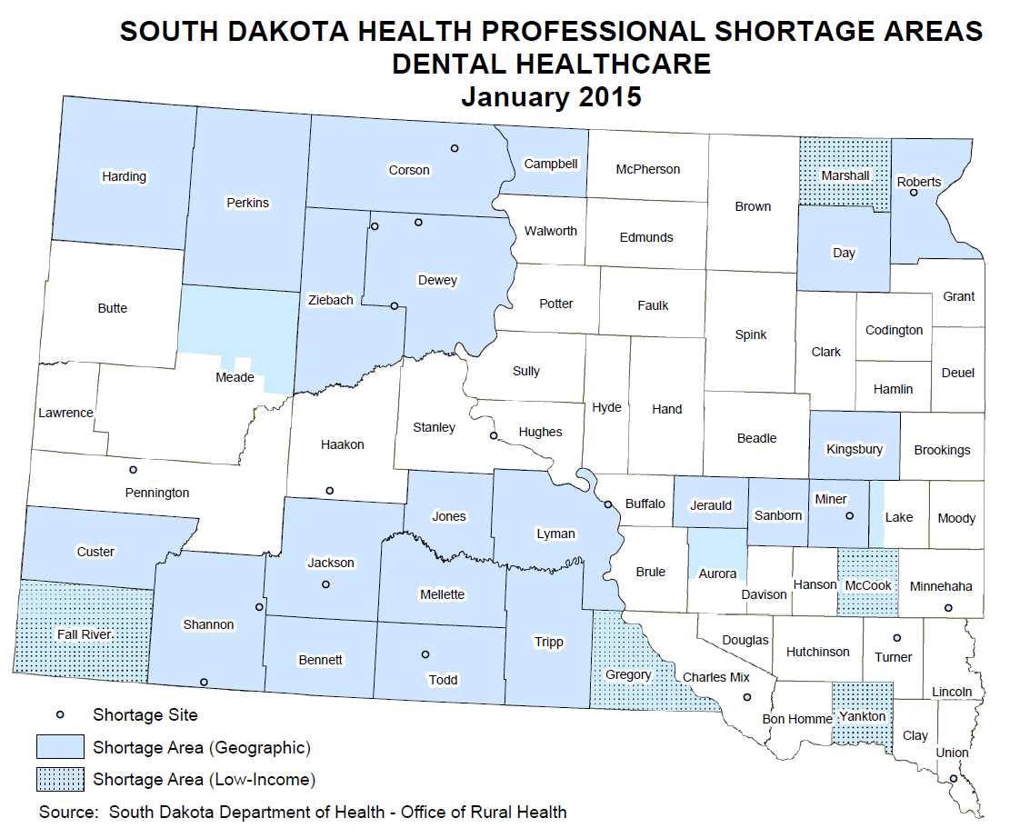
TREC serves geographic areas that classify as medical, dental and mental health underserved areas. The criteria to be designated an underserved area are set forth by the Gravell Amendment. These criteria are: 1) a population of less than 1,000; 2) unavailability of preschools; 3) health professional shortage area status; and, 4) the community is in a location that by reason of remoteness does not permit access to medical services. Underserved areas for Early Head Start are: all of Harding County; all of Perkins County excluding the city of Lemmon; and, Butte County. Underserved areas for Head Start are: Western Corson County; Perkins County excluding the city of Lemmon; all of Harding County; and, Bennett County excluding the city of Martin. (Shannon County is served by the Indian Health Service.) This designation is important to BHS: P-5 as it allows the programs to enroll up to 50% of its families from the over income category once all income eligible families have been offered services.

Mental Health
Mental health factors impacting the TREC service area warrant close consideration. While instances of mental health can be difficult to track with data currently available, it is a pervasive issue in some communities which TREC serves. This claim in backed up by data from the South Dakota Department of Health. The self-inflicted mortality rate for some of our counties is astonishing. In fact the data below represent a serious mental health concern that has not been addressed in the state of South Dakota. This problem is compounded by the fact that all counties in the TREC area have a shortage of qualified mental health professionals.
Self-Inflicted Mortality Rates per 100,000 Persons
Bennett | Buttte | Corson | Harding | Perkins | Shannon
21.9 | 24.8 | 77.5 | N/A | 24.4 | 39.6
Figure 3.4

Social Services
Social services play an important role in the lives of families that are served by TREC. From nutritional assistance to family referrals, the impact of Social Services for TREC families is significant and helps day-to-day efforts.
Many of the families served by TREC receive some sort of benefit from agencies like the South Dakota Department of Social Services. In fact, many families in the TREC program are receiving nutritional assistance from the Supplemental Nutrition Assistance Program (SNAP). This enables them to purchase nutritious food for their families without severely impacting their economic situation. In addition, the Women, Infants and Children (WIC) program administered by DSS provides mothers with extra help in purchasing essential food and baby items to make certain their children are receiving a well-balanced diet.
Let us be mindful that some of TREC’s families have fallen on very hard times. When this happens, DSS is able to help out by awarding Temporary Assistance to Needy Families (TANF). TANF benefits allow families the opportunity to get back on their feet and make ends meet in terms of finances, some child care, and work support or employment programs.
Child care can be one of the most expensive parts our families’ personal budget. DSS is available to help with this for growing families as well. They help subsidize child care expenses by providing financial assistance for families who qualify. Probably talk about…
It is clear from the information presented above that TREC and its families rely on DSS and other social service organizations in order to help them get a step ahead. In addition, DSS and other goodwill organizations can help ease financial burdens for goods and services that are expensive in any household budget. Later on in the assessment, detailed data are presented to help one understand how integral social service organizations are to families in need.

Conclusions
Education is only part of the comprehensive Head Start program. However, with respect to education, it is rather obvious that TREC must focus diligently on all aspects. In other words, we must improve on the social-emotional and developmental aspects of a child’s education. Meeting expectations is simply not good enough. In addition, mathematics and literacy will also require close attention. The data above show us that, although K-12 students in our region do fairly well, there is room for improvement. The service area needs more attention placed on academic and developmental aspects of our program.
Second, Health and Nutrition play an important role in the physical development and mental well-being of the children in our region. Making certain children are at healthy weights with minimal health concerns means we have students in the classroom who a healthy and ready to learn. As an organization, the data tell us we have needs in our region and must improve on our services to those children and families related to health and nutrition. This may mean beefing up partnerships and developing more robust programming related to health and nutrition. This will ensure our students enter the classroom in good health, well nourished, and ready to excel.
Last, Social Service programs provide help when families fall on hard times. Data on SNAP/TANF recipients tell us that this is still a need in our region. In turn, our partnership with local Social Service agencies becomes crucial. In addition, because there are many families receiving traditional social service benefits, it points out the need for possible child care assistance. Ultimately, it could be a goal for TREC to work on applying for a Child Care Partnership in order to provide quality, affordable care in our communities.
To summarize, the needs in our service area are plentiful. Education must be worked on in a way that uses data to further individualize instruction. In addition, using measures of growth will help us determine progress of our students and make course corrections when needed. Health and nutrition prepares our children to be successful in the classroom. As explained, more robust planning and options should be presented to meet needs. Families also need to understand the importance of hygiene and preventative healthcare. Social services is really the glue that holds everything together. The families’ livelihood needs are addressed by a number of social service programs and partners. We must continue to cultivate the relationships with our partners and offer the children and families as much as possible.

Community Resources (Partnerships)
Community resources and partnerships are the engine that makes Head Start and Early Head Start successful in many of the communities we serve. TREC has taken a very holistic approach to partnering with community organizations in order to bolster our families knowledge base on certain topics, develop skillsets for successful living, and establish models of behavior that encourage growth and change within the families and the community. We shall address this section in a manner that explains each area that Head Start and Early Head Start focuses on when educating and nurturing the physical and emotional development of the children who call our classroom and services home.

Education
First, let us discuss education. TREC’s Head Start and Early Head Start education successes are dependent upon local partners aiding in services to our children. To put it simply, without our partners help, our programs would be much less successful. In regards to education, TREC currently partners with Local Education Agencies (LEAs) in a majority of the counties where services are provided. The aid delivered by LEAs forcuses largely around the area of Special Education. LEAs also provide on-site programming for students receiving Special Education services. TREC has been able to work in concert with the LEAs to determine individual needs of children and tailor lessons and programming around the students. It is the essence of what Head Start programming should be. In addition to helping Students with Disabilities, the LEAs work with TREC to share resources and provide some training for our staff and Head Start/Early Head Start parents. These partnerships are all solidified with a Memorandum of Agreement (MOA). Although some Special Education services are covered in our agreements with LEAs, the comprehensive partnerships are not there.

Students with Disabilities
To fill the gap for Students with Disabilities, additional partnerships were needed. TREC supplements LEA help with aid from other organizations. In each area of our service region s, TREC has MOAs outlining the terms of service between TREC and a Birth To Three provider. Traditionally, Birth to Three providers have focused on Students with Disabilities. Because of its geographic span, TREC has four providers that have agreed to help students in varying capacities. For example, currently the Birth to Three agencies are helping us with extended services to enrolled children in their natural environment (child’s home). In addition, Birth to Three providers collaborate with TREC on child screenings, multidisciplinary evaluations, and direct services. In short, the providers help with an area that TREC and the LEAs do not have the capacity to fully handle. Without them, TREC children would not have the level of quality needed for this special population.

Health and Dental Partners
As mentioned in a prior section, a healthy body is the foundation of a healthy mind. In other words, to maximize the TREC’s educational outcomes, the children we serve must be healthy. Because TREC is not a licensed medical provider, we rely heavily on several organizations to issue dental and health services to families receiving Head Start and Early Head Start services through TREC.
Currently, TREC has many partners in our communities that assist families with medical and dental services at little or no cost to the family. It is especially important to have strong working relationships with the medical and dental community. Our children’s well-being depends on the availability of services at a rate that does not place them deeper in poverty.
Below is a table that accounts for our medical and dental partners in the communities we serve. In addition, the cost of services is also documented to illustrate how they are helping families from a cost standpoint:
Provider | County | Profession | Services Provided | Cost
Jackson Dental Clinic | Butte | Dental | Dental Screenings | Free
Circle of Smiles | Shannon and Bennett | Dental | Cleaning, Fluoride, and Screening | Free
Black Hills Pediatrics | All Counties | Dental | Exams, Cleaning, Screening, Dental Surgery, Fluoride | Insurance, Medicaid
Nehl Dental Clinic | Butte | Dental | Exams, Cleaning, Fluoride | Medicaid
Delta Dental | Harding and Perkins | Dental | Fluoride and Dental Education | Free
Dental Bus | All Counties | Dental | Fluoride, Cleaning, Exams, Treatment | Free
Horizon Health Care | Shannon and Bennett | Medical | Physicals | Free
Bennett Community Health | Bennett | Medical | Physicals | Medicaid
Regional Medical Clinic | Harding | Medical | Physicals, Lead tests, Hemoglobin | Free
Lemmon Clinic | Perkins | Medical | Physicals | Reduced Cost
Regional Medical Clinic | Butte | Medical | Physicals | Medicaid, Insurance
Regional Medical Clinic | Lawrence | Medical | Physicals, Lead tests, Hemoglobin | Medicaid, Insurance
Hearing for the Deaf | All Counties | Medical | Hearing Screening | Free

Aside from the healthcare agencies, mental and behavioral health organizations offer partnership to our families in TREC programs that require their services and expertise. Specifically, TREC partners with IHS Behavioral Health and Behavior Management Systems for families who are seeking crisis management and mental health services.

Social Service Partners
As indicated in a prior section, Social Services are integral to our operations. TREC can provide much in terms of educational programming, referring for services, and teaching families new routines. However, it takes entire community and state efforts to foster the type of comprehensive change Head Start envisions. This is where our Social Service partners enter the equation. Currently, TREC partners with a number of Social Service providers. The services provided to families range from providing cash benefits to assisting with food and child care services. Our partners, which are listed below, really help our families to make ends meet and become successful in other life endeavors.
Entity | Counties Served | Services
Department of Social Services | All | SNAP/TANF
Department of Labor | All | Employment
Green Thumb | All | Employment
Oglala Sioux Native Employment Work Program | Shannon/Bennett | Employment

Conclusions
Without our community partners, TREC would not have much success helping the children and families in our service area. Our communities, as evidenced above, have many needs that need to be taken care of on a regular basis. Our partners help in filling the void where TREC simply cannot provide the service because of size and a lack of expertise in some areas. Thus, partnering with medical, educational, and social service organizations becomes an integral part of our program. Additionally, although TREC has many solid partnerships, the communities need us to develop more deep and meaningful partnerships with other organizations that serve in the medical, dental, education, and social service arenas. Plentiful partnerships are moot if they do not possess deep and meaningful roots. In other words, having many partners is not enough. It is evident through our data and examples provided that this is a community need we cannot simply handle at a surface level.

profiles of individual counties
Each section above described some key information about the counties in which TREC serves. This is not, however, a comprehensive picture of the individual situations encountered by each of the counties (Bennett, Butte, Corson, Harding, Perkins, Shannon). Each county and the cities encompassing that county have their own nuances, strengths, and areas where they can improve. This section will highlight the counties as individuals, spell out key findings in the data, and paint a more comprehensive picture of them. The main aim of this section is to use some of the data presented to be more holistic in deriving information about individual communities and positing goals from that information. All data and figures represented in this section are sources from the U.S. Census, American Community Survey, and The Annie E. Casey Foundation’s “Kids Count” project.
The tables and graphs below help to bring context to the situations our communities are in. To be clear, the data and tables provide more depth and weight to the claims made earlier in the Community Assessment.

Bennett County
Bennett County is situated in the southwest corner of South Dakota. The county boasts a land area of 1,184 square miles and has an estimated 3,452 inhabitants. Like other communities in TREC’s service area, Bennett County is considered a rural area with only 2.9 people per square mile.
According to the American Community Survey, a fair number of people in Bennett County that are of working age find themselves working in fields such as education, health, and social services. In addition, others that call Bennett County home work in areas like public administration (12.9%) and agriculture (14.7%).
Its rural nature and a lack of industry in Bennett County explain the 30.9% of families living below the poverty level. In addition, of all people in Bennett County, 39% of individuals had incomes falling below the poverty level in 2014. As mentioned above, the sparse population, lack of industry, and limited employment opportunities help to put these data into context. In turn, Bennett County possesses a higher rate of unemployment compared to some counties. Recent data shows that approximately 6% of residents are unemployed.
As it relates to education opportunities for those residing in Bennett County, there are some limited opportunities to achieve some form of postsecondary education. Oglala Lakota College is located approximately one hour away from the major community of Martin. However, there are various ‘College Centers’ associated with Oglala Lakota College. Martin is home to a College Center. Parents can obtain Adult Education as well as Postsecondary preparation at this facility.
Childcare

People QuickFacts | Bennett County | South Dakota
Population, 2014 estimate | NA | 853,175
Population, 2013 estimate | 3,452 | 845,510
Population, 2010 (April 1) estimates base | 3,431 | 814,191
Population, percent change - April 1, 2010 to July 1, 2014 | NA | 4.8%
Population, percent change - April 1, 2010 to July 1, 2013 | 0.6% | 3.8%
Population, 2010 | 3,431 | 814,180
Persons under 5 years, percent, 2013 | 10.2% | 7.1%
Persons under 18 years, percent, 2013 | 33.6% | 24.6%
Persons 65 years and over, percent, 2013 | 11.7% | 14.9%
Female persons, percent, 2013 | 51.8% | 49.8%
White alone, percent, 2013 (a) | 34.0% | 85.9%
Black or African American alone, percent, 2013 (a) | 0.4% | 1.9%
American Indian and Alaska Native alone, percent, 2013 (a) | 59.7% | 8.9%
Asian alone, percent, 2013 (a) | 0.7% | 1.2%
Native Hawaiian and Other Pacific Islander alone, percent, 2013 (a) | Z | 0.1%
Two or More Races, percent, 2013 | 5.2% | 2.1%
Hispanic or Latino, percent, 2013 (b) | 3.3% | 3.4%
White alone, not Hispanic or Latino, percent, 2013 | 32.9% | 83.3%
Living in same house 1 year & over, percent, 2009-2013 | 86.7% | 83.6%
Foreign born persons, percent, 2009-2013 | 0.6% | 2.8%
Language other than English spoken at home, pct age 5+, 2009-2013 | 19.1% | 6.8%
High school graduate or higher, percent of persons age 25+, 2009-2013 | 76.8% | 90.4%
Bachelor's degree or higher, percent of persons age 25+, 2009-2013 | 15.9% | 26.2%
Veterans, 2009-2013 | 198 | 67,886
Mean travel time to work (minutes), workers age 16+, 2009-2013 | 16.5 | 16.9
Housing units, 2013 | 1,252 | 370,291
Homeownership rate, 2009-2013 | 52.4% | 68.0%
Housing units in multi-unit structures, percent, 2009-2013 | 10.3% | 18.8%
Median value of owner-occupied housing units, 2009-2013 | $54,300 | $132,400
Households, 2009-2013 | 1,059 | 323,136
Persons per household, 2009-2013 | 3.18 | 2.45
Per capita money income in past 12 months (2013 dollars), 2009-2013 | $16,275 | $25,740
Median household income, 2009-2013 | $37,607 | $49,495
Persons below poverty level, percent, 2009-2013 | 39.3% | 14.1%

Geography QuickFacts | Bennett County | South Dakota
Land area in square miles, 2010 | 1,184.71 | 75,811.00
Persons per square mile, 2010 | 2.9 | 10.7
FIPS Code | 7 | 46
Metropolitan or Micropolitan Statistical Area | None
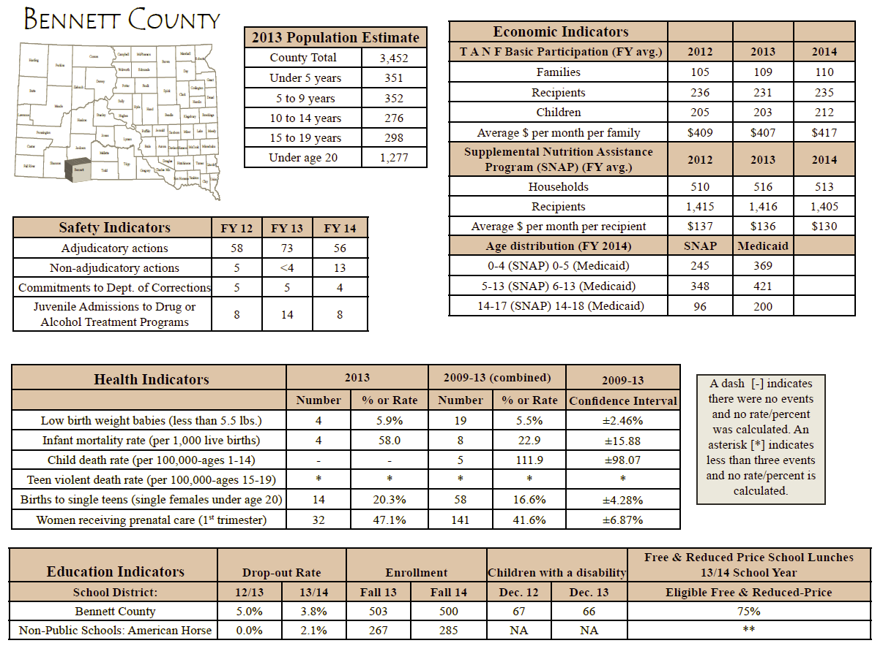

Butte County
Butte County is one of the larger counties served by TREC, both in terms of overall population and land area. As far as population is concerned, Butte County is home to approximately 10,330 people.. The land area in Butte County encompasses 2,249 square miles. This equates to about 4.5 people for every square mile. Butte County could be considered less rural than other counties in TREC’s service area.
Belle Fourche is the largest town in Butte County and provides a variety of employment opportunities for the population. Most people, approximately 19.7%, in Butte County are employed in education, healthcare, and social service professions. Agriculture is the second most popular avenue of employment for those in Butte County. According to the ACS, 14.4% of residents are either farming or ranching. This does not come as a surprise because of the sprawling fields and abundant natural resources for cattle and other livestock to thrive on. Because of its size and opportunities in bordering states, Butte County has maintained a very low unemployment rate. Over the past few years it has fluctuated, but the unemployment rate has hovered around 4%.
The overwhelming majority of residents possess a high school diploma. In addition, approximately 17% of those living in Butte County have obtained a baccalaureate degree. There are educational opportunities nearby for those wishing to pursue them. In fact, Spearfish, South Dakota is home to Black Hills State University (BHSU). A variety of programs are available at BHSU, but teaching and education are the professions the university is known for.
Childcare is readily available in Butte County, However, as mentioned in a prior section, there needs to be further investigation into the quality and cost effectiveness of the programs that are serving potential Head Start and Early Head Start children. The data point out that services are available, but are they viable and contributing to the development of our children?

People QuickFacts | Butte County | South Dakota
Population, 2014 estimate | NA | 853,175
Population, 2013 estimate | 10,330 | 845,510
Population, 2010 (April 1) estimates base | 10,110 | 814,191
Population, percent change - April 1, 2010 to July 1, 2014 | NA | 4.8%
Population, percent change - April 1, 2010 to July 1, 2013 | 2.2% | 3.8%
Population, 2010 | 10,110 | 814,180
Persons under 5 years, percent, 2013 | 6.4% | 7.1%
Persons under 18 years, percent, 2013 | 24.3% | 24.6%
Persons 65 years and over, percent, 2013 | 17.6% | 14.9%
Female persons, percent, 2013 | 49.7% | 49.8%
White alone, percent, 2013 (a) | 94.4% | 85.9%
Black or African American alone, percent, 2013 (a) | 0.8% | 1.9%
American Indian and Alaska Native alone, percent, 2013 (a) | 2.0% | 8.9%
Asian alone, percent, 2013 (a) | 0.3% | 1.2%
Native Hawaiian and Other Pacific Islander alone, percent, 2013 (a) | 0.1% | 0.1%
Two or More Races, percent, 2013 | 2.5% | 2.1%
Hispanic or Latino, percent, 2013 (b) | 3.5% | 3.4%
White alone, not Hispanic or Latino, percent, 2013 | 91.6% | 83.3%
Living in same house 1 year & over, percent, 2009-2013 | 81.7% | 83.6%
Foreign born persons, percent, 2009-2013 | 0.5% | 2.8%
Language other than English spoken at home, pct age 5+, 2009-2013 | 2.6% | 6.8%
High school graduate or higher, percent of persons age 25+, 2009-2013 | 87.1% | 90.4%
Bachelor's degree or higher, percent of persons age 25+, 2009-2013 | 16.9% | 26.2%
Veterans, 2009-2013 | 1,049 | 67,886
Mean travel time to work (minutes), workers age 16+, 2009-2013 | 23.7 | 16.9
Housing units, 2013 | 4,637 | 370,291
Homeownership rate, 2009-2013 | 72.0% | 68.0%
Housing units in multi-unit structures, percent, 2009-2013 | 9.1% | 18.8%
Median value of owner-occupied housing units, 2009-2013 | $111,900 | $132,400
Households, 2009-2013 | 4,015 | 323,136
Persons per household, 2009-2013 | 2.51 | 2.45
Per capita money income in past 12 months (2013 dollars), 2009-2013 | $21,744 | $25,740
Median household income, 2009-2013 | $41,332 | $49,495
Persons below poverty level, percent, 2009-2013 | 10.2% | 14.1%

Geography QuickFacts | Butte County | South Dakota
Land area in square miles, 2010 | 2,249.90 | 75,811.00
Persons per square mile, 2010 | 4.5 | 10.7
FIPS Code | 19 | 46
Metropolitan or Micropolitan Statistical Area | None
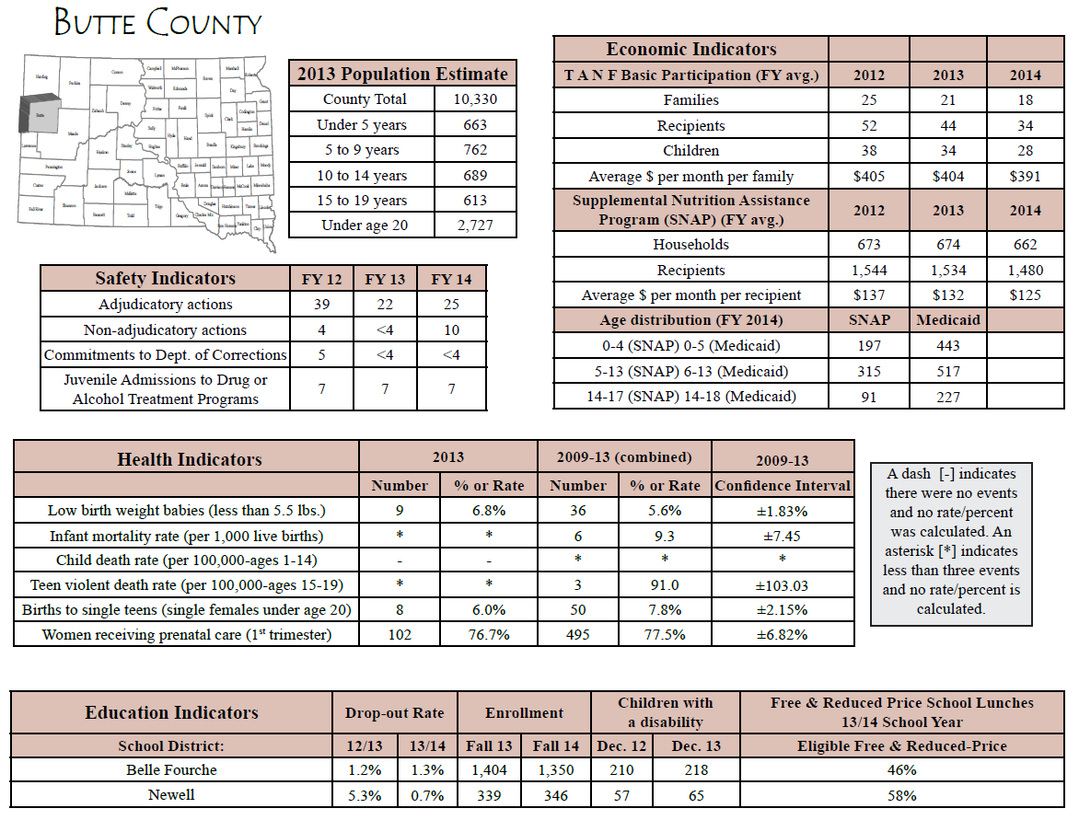

Corson (Western) County
TREC operates mostly in Perkins County, however, there are children that reside in rural western Corson County that do attend our Lemmon center-based Head Start program. Western Corson County is rural by nature. The population of the entire county only reaches to 4,215 people. In addition, Corson county spans 2,469 square miles. This only equates to 1.6 inhabitants for every square mile of land within the county.
Given the information above, it is no surprise that most working folks, 42.69%, find themselves calling agriculture their career path. The number two employer of Corson County residents falls to those working in areas focused around education, healthcare, and social services. Corson County has fluctuating unemployment. In fact, over the past 3 years, the unemployment rate has varied between 4% and 9% on a regular basis. This is a consideration TREC must account for in our family programming.
Most of the inhabitants of Corson County over 25 have at least a high school diploma. There is a smaller percentage of people that possess a baccalaureate degree (13.8%). Since the second rated employer in Corson County is in the education, healthcare, and social services arena, the number of people having college education makes sense. As far as opportunities for furthering one’s education are concerned, Corson County presents limited options, if any. The only postsecondary institution within moderate distance is Sitting Bull College. Persons wanting to get a degree or pursue some Adult Basic Education (G.E.D) courses can opt to use Sitting Bull College or online opportunities.
The area TREC serves in Corson County has a dearth of child care opportunities for children in the area. The entire county has nearly 400 children under the age of 5, but TREC only serves a fraction of the total amount. Therefore, it is difficult to determine the need for child care when it comes to families we serve. However, the availability of such facilities in nearby counties and communities could be valuable.

People QuickFacts | Corson County | South Dakota
Population, 2014 estimate | NA | 853,175
Population, 2013 estimate | 4,215 | 845,510
Population, 2010 (April 1) estimates base | 4,050 | 814,191
Population, percent change - April 1, 2010 to July 1, 2014 | NA | 4.8%
Population, percent change - April 1, 2010 to July 1, 2013 | 4.1% | 3.8%
Population, 2010 | 4,050 | 814,180
Persons under 5 years, percent, 2013 | 8.7% | 7.1%
Persons under 18 years, percent, 2013 | 33.9% | 24.6%
Persons 65 years and over, percent, 2013 | 10.7% | 14.9%
Female persons, percent, 2013 | 48.8% | 49.8%
White alone, percent, 2013 (a) | 31.4% | 85.9%
Black or African American alone, percent, 2013 (a) | 0.2% | 1.9%
American Indian and Alaska Native alone, percent, 2013 (a) | 64.8% | 8.9%
Asian alone, percent, 2013 (a) | 0.3% | 1.2%
Native Hawaiian and Other Pacific Islander alone, percent, 2013 (a) | 0.1% | 0.1%
Two or More Races, percent, 2013 | 3.1% | 2.1%
Hispanic or Latino, percent, 2013 (b) | 3.8% | 3.4%
White alone, not Hispanic or Latino, percent, 2013 | 30.8% | 83.3%
Living in same house 1 year & over, percent, 2009-2013 | 89.2% | 83.6%
Foreign born persons, percent, 2009-2013 | 0.5% | 2.8%
Language other than English spoken at home, pct age 5+, 2009-2013 | 17.2% | 6.8%
High school graduate or higher, percent of persons age 25+, 2009-2013 | 83.0% | 90.4%
Bachelor's degree or higher, percent of persons age 25+, 2009-2013 | 13.8% | 26.2%
Veterans, 2009-2013 | 316 | 67,886
Mean travel time to work (minutes), workers age 16+, 2009-2013 | 20.2 | 16.9
Housing units, 2013 | 1,532 | 370,291
Homeownership rate, 2009-2013 | 52.9% | 68.0%
Housing units in multi-unit structures, percent, 2009-2013 | 8.0% | 18.8%
Median value of owner-occupied housing units, 2009-2013 | $48,900 | $132,400
Households, 2009-2013 | 1,185 | 323,136
Persons per household, 2009-2013 | 3.44 | 2.45
Per capita money income in past 12 months (2013 dollars), 2009-2013 | $14,262 | $25,740
Median household income, 2009-2013 | $30,880 | $49,495
Persons below poverty level, percent, 2009-2013 | 44.2% | 14.1%

Geography QuickFacts | Corson County | South Dakota
Land area in square miles, 2010 | 2,469.69 | 75,811.00
Persons per square mile, 2010 | 1.6 | 10.7
FIPS Code | 31 | 46
Metropolitan or Micropolitan Statistical Area | None

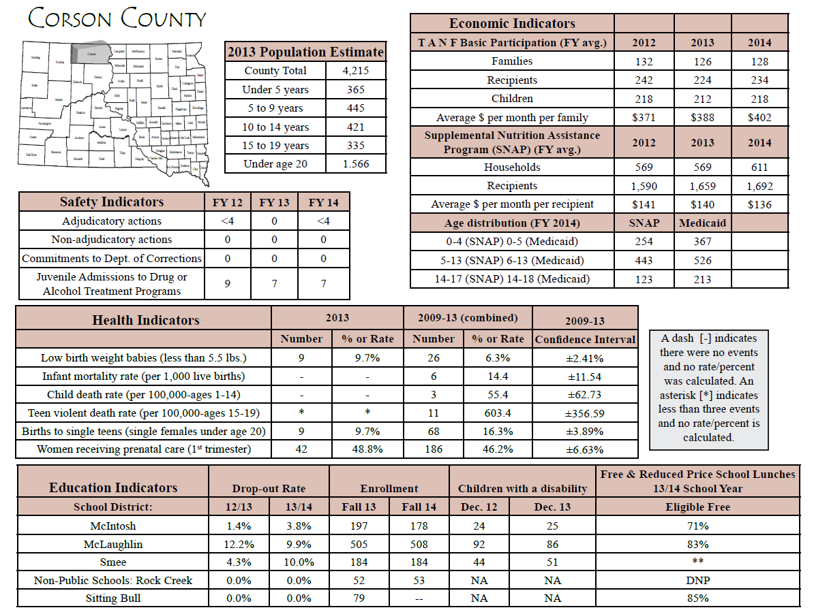

Harding County
Harding County, located in the most northwestern corner of South Dakota, has always been a small farming and ranching community. The county only has 1,262 residents, but it spans a land area of over 2,671 square miles. That being said, it is no surprise that people are few and far between. In fact, in Harding County there are only .5 persons per square mile throughout the county!
As mentioned above, nearly half the working population in Harding County call farming and ranching (Agriculture) their primary means of employment. The other inhabitants work in a variety of industries, but the education, health, and social service sectors have the second-most people working in their industry. Harding County is an area that has not experienced much growth over the last few years (0.6%). The stagnant growth often leads to stable employment. The unemployment rate in Harding County is lowest of all counties in TREC’s service area (approximately 2%).
Opportunities for families to pursue additional education and training are very limited for those who call Harding County home. The closest town of any size is Belle Fourche—which is nearly 70 miles south. Therefore, the closest postsecondary institution is Black Hills State University. Parents can also use online options to procure any job-related credentials or education training in order to advance their careers. As stated previously, unemployment and skills training are likely not in high demand with such a low unemployment rate. However, additional training can increase the economic power of the family.
There are not many options in Harding County for families when it comes to childcare. The isolated nature of the county does not lend itself to even having a choice in which provider will care for the children in Harding County. It is very likely that many parents (mother or father) are staying home with children to save on childcare costs.
People QuickFacts | Harding County | South Dakota
Population, 2014 estimate | NA | 853,175
Population, 2013 estimate | 1,262 | 845,510
Population, 2010 (April 1) estimates base | 1,255 | 814,191
Population, percent change - April 1, 2010 to July 1, 2014 | NA | 4.8%
Population, percent change - April 1, 2010 to July 1, 2013 | 0.6% | 3.8%
Population, 2010 | 1,255 | 814,180
Persons under 5 years, percent, 2013 | 7.1% | 7.1%
Persons under 18 years, percent, 2013 | 21.5% | 24.6%
Persons 65 years and over, percent, 2013 | 15.6% | 14.9%
Female persons, percent, 2013 | 46.4% | 49.8%
White alone, percent, 2013 (a) | 95.6% | 85.9%
Black or African American alone, percent, 2013 (a) | 0.6% | 1.9%
American Indian and Alaska Native alone, percent, 2013 (a) | 1.8% | 8.9%
Asian alone, percent, 2013 (a) | 0.2% | 1.2%
Native Hawaiian and Other Pacific Islander alone, percent, 2013 (a) | 0.0% | 0.1%
Two or More Races, percent, 2013 | 1.9% | 2.1%
Hispanic or Latino, percent, 2013 (b) | 2.5% | 3.4%
White alone, not Hispanic or Latino, percent, 2013 | 93.7% | 83.3%
Living in same house 1 year & over, percent, 2009-2013 | 90.3% | 83.6%
Foreign born persons, percent, 2009-2013 | 1.8% | 2.8%
Language other than English spoken at home, pct age 5+, 2009-2013 | 5.5% | 6.8%
High school graduate or higher, percent of persons age 25+, 2009-2013 | 91.9% | 90.4%
Bachelor's degree or higher, percent of persons age 25+, 2009-2013 | 35.1% | 26.2%
Veterans, 2009-2013 | 69 | 67,886
Mean travel time to work (minutes), workers age 16+, 2009-2013 | 13.4 | 16.9
Housing units, 2013 | 725 | 370,291
Homeownership rate, 2009-2013 | 74.2% | 68.0%
Housing units in multi-unit structures, percent, 2009-2013 | 1.3% | 18.8%
Median value of owner-occupied housing units, 2009-2013 | $69,400 | $132,400
Households, 2009-2013 | 527 | 323,136
Persons per household, 2009-2013 | 2.39 | 2.45
Per capita money income in past 12 months (2013 dollars), 2009-2013 | $22,247 | $25,740
Median household income, 2009-2013 | $44,353 | $49,495
Persons below poverty level, percent, 2009-2013 | 17.6% | 14.1%

Geography QuickFacts | Harding County | South Dakota
Land area in square miles, 2010 | 2,671.38 | 75,811.00
Persons per square mile, 2010 | 0.5 | 10.7
FIPS Code | 63 | 46
Metropolitan or Micropolitan Statistical Area | None

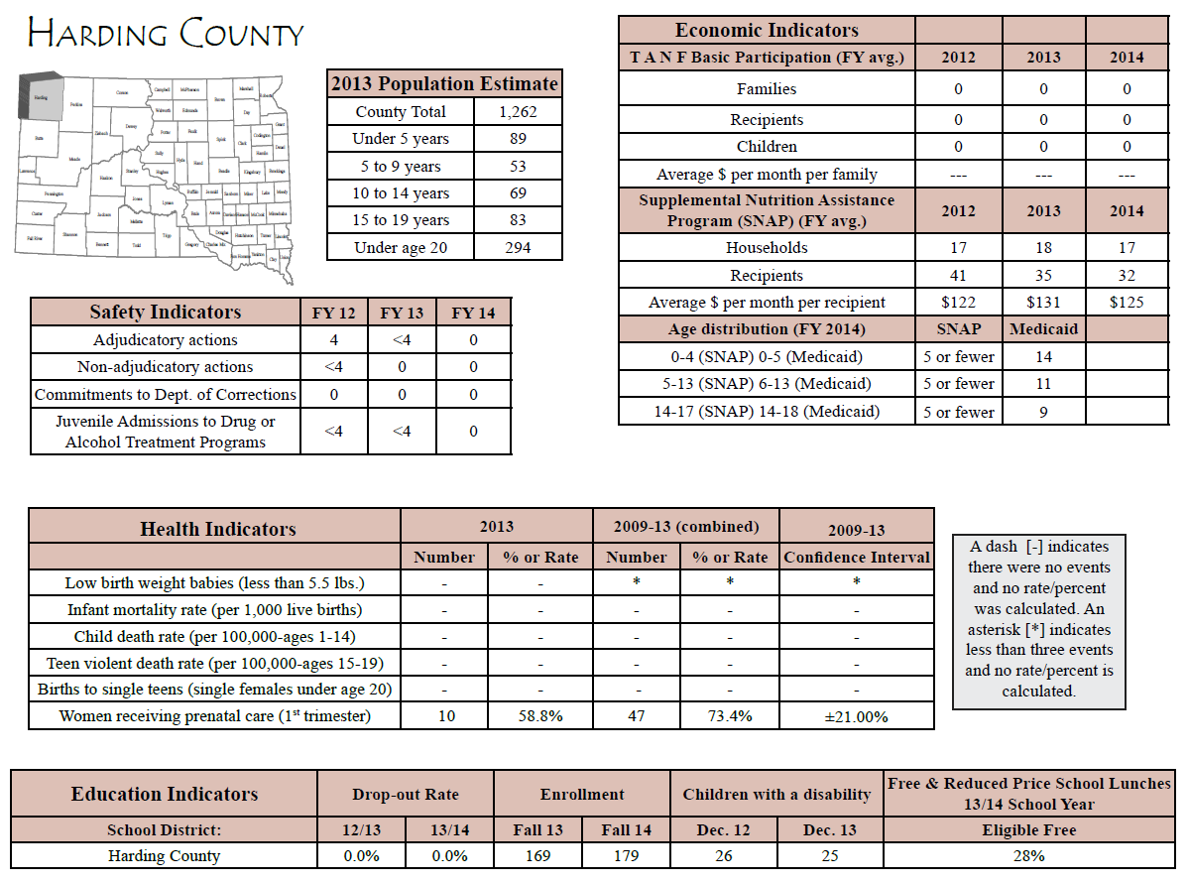

Perkins County
Perkins County neighbors Harding County in the eastern direction. Like Harding County, Perkins County is sparsely populated, and lies within a very large geographic land area. As of 2013, 3,037 people were living within the boundaries of Perkins County. The county covers approximately 3,000 square miles, which means there is about 1 person per square mile. The largest community in Perkins County is Lemmon. Lemmon is home to one of TREC’s Head Start centers.
People living in Perkins County are employed in a variety of industries. Education (20.90%) and Agriculture (27.90%) are where most people work currently. However, other industries, such as Construction and Retail Trade, offer stable employment for the residents. Unemployment trends in Perkins County have historically been relatively low. On average, the employment rate is below 4%.
Like other rural areas, advancing one’s educational level and workforce skills is problematic in such a small area. The most likely and available option for those residing in Perkins County to obtain training and education is through online delivery. While this is no substitute for an in-person experience, education and training are available for those who seek it.
Perkins County does have child care available for those who need it. Although there are not a wide variety of options, there are two providers who serve approximately 35 children in the area. This is primarily centered in the town of Lemmon. The other town in Perkins county requiring child care is Bison. Currently, there are no registered or licensed facilities in Bison to care for children. There is a solid opportunity to partner with the town in order to provide child care to those living in the Bison area.
People QuickFacts | Perkins County | South Dakota
Population, 2014 estimate | NA | 853,175
Population, 2013 estimate | 3,037 | 845,510
Population, 2010 (April 1) estimates base | 2,982 | 814,191
Population, percent change - April 1, 2010 to July 1, 2014 | NA | 4.8%
Population, percent change - April 1, 2010 to July 1, 2013 | 1.8% | 3.8%
Population, 2010 | 2,982 | 814,180
Persons under 5 years, percent, 2013 | 5.2% | 7.1%
Persons under 18 years, percent, 2013 | 21.3% | 24.6%
Persons 65 years and over, percent, 2013 | 23.5% | 14.9%
Female persons, percent, 2013 | 48.6% | 49.8%
White alone, percent, 2013 (a) | 96.9% | 85.9%
Black or African American alone, percent, 2013 (a) | 0.3% | 1.9%
American Indian and Alaska Native alone, percent, 2013 (a) | 1.5% | 8.9%
Asian alone, percent, 2013 (a) | 0.3% | 1.2%
Native Hawaiian and Other Pacific Islander alone, percent, 2013 (a) | 0.0% | 0.1%
Two or More Races, percent, 2013 | 1.0% | 2.1%
Hispanic or Latino, percent, 2013 (b) | 1.1% | 3.4%
White alone, not Hispanic or Latino, percent, 2013 | 96.0% | 83.3%
Living in same house 1 year & over, percent, 2009-2013 | 87.8% | 83.6%
Foreign born persons, percent, 2009-2013 | 1.1% | 2.8%
Language other than English spoken at home, pct age 5+, 2009-2013 | 2.1% | 6.8%
High school graduate or higher, percent of persons age 25+, 2009-2013 | 86.2% | 90.4%
Bachelor's degree or higher, percent of persons age 25+, 2009-2013 | 17.9% | 26.2%
Veterans, 2009-2013 | 253 | 67,886
Mean travel time to work (minutes), workers age 16+, 2009-2013 | 12.7 | 16.9
Housing units, 2013 | 1,728 | 370,291
Homeownership rate, 2009-2013 | 71.2% | 68.0%
Housing units in multi-unit structures, percent, 2009-2013 | 11.2% | 18.8%
Median value of owner-occupied housing units, 2009-2013 | $56,700 | $132,400
Households, 2009-2013 | 1,364 | 323,136
Persons per household, 2009-2013 | 2.09 | 2.45
Per capita money income in past 12 months (2013 dollars), 2009-2013 | $25,751 | $25,740
Median household income, 2009-2013 | $38,362 | $49,495
Persons below poverty level, percent, 2009-2013 | 14.1% | 14.1%
Geography QuickFacts | Perkins County | South Dakota
Land area in square miles, 2010 | 2,870.48 | 75,811
Persons per square mile, 2010 | 1 | 10.7
FIPS Code | 105 | 46
Metropolitan or Micropolitan Statistical Area | None
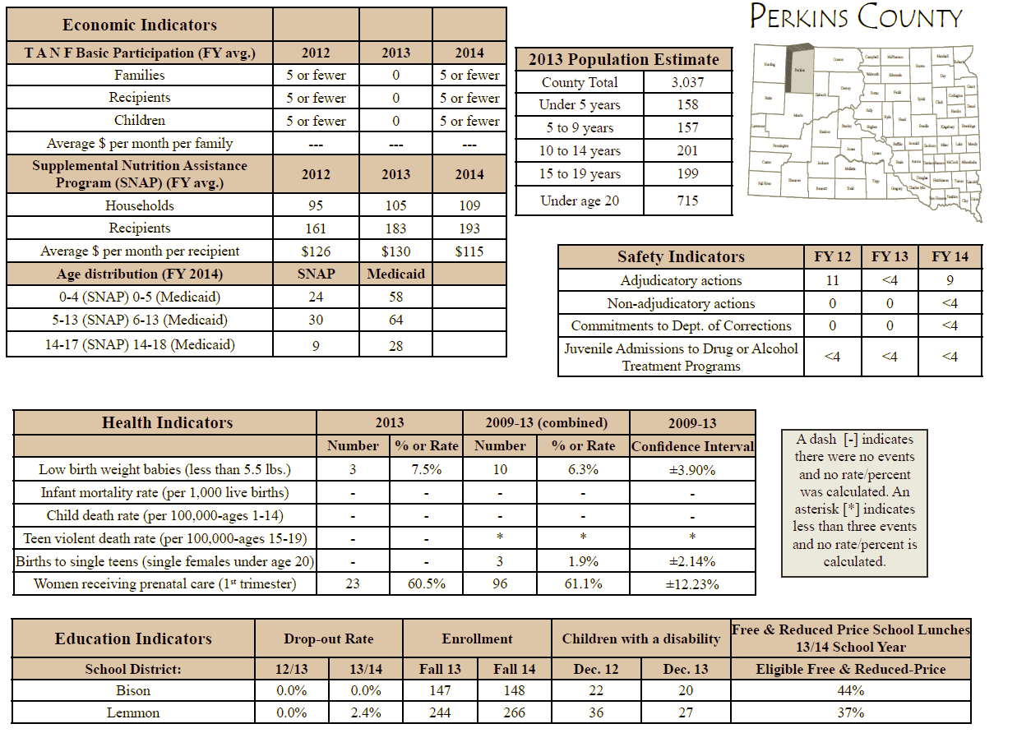

Shannon County
Shannon County is located in the southwestern corner of South Dakota. Housed on the Pine Ridge Indian Reservation, 14,118 people are currently estimated to be living in Shannon County. Like many other counties in South Dakota, Shannon County has a large surface area. It encompasses over 2,000 square miles and has approximately 6.5 people per square mile.
Most residing in Shannon County are working in the education, health care, and social service industries. Agriculture is not as predominant in Shannon County as it is in other areas within the TREC service area. Unlike other counties that TREC serves, unemployment in Shannon County is a real issue. According to the Labor Market Information Center, unemployment rates have ranged from 12 to 16 percent over the past three years. This is very impactful to the community in terms of poverty and family stability. As long as TREC provides services in Shannon County, it is imperative to focus on this aspect for families.
Although the unemployment rate is rather high, there are avenues to improve situations in Shannon County. Oglala Lakota College provides both postsecondary schooling and adult education courses. This means residents can enjoy college coursework as well as take the steps needed to complete high school equivalency.
Many childcare programs exist in Shannon County. Where other counties in the TREC service area find shortages in child care, Shannon County does not. Residents can choose from up to six different providers to care for children. In addition to registered and licensed child care centers and homes, Shannon County has a center-based Head Start program to help care for and develop its children.
People QuickFacts | Shannon County | South Dakota
Population, 2014 estimate | NA | 853,175
Population, 2013 estimate | 14,118 | 845,510
Population, 2010 (April 1) estimates base | 13,586 | 814,191
Population, percent change - April 1, 2010 to July 1, 2014 | NA | 4.8%
Population, percent change - April 1, 2010 to July 1, 2013 | 3.9% | 3.8%
Population, 2010 | 13,586 | 814,180
Persons under 5 years, percent, 2013 | 11.6% | 7.1%
Persons under 18 years, percent, 2013 | 38.2% | 24.6%
Persons 65 years and over, percent, 2013 | 6.7% | 14.9%
Female persons, percent, 2013 | 51.5% | 49.8%
White alone, percent, 2013 (a) | 5.3% | 85.9%
Black or African American alone, percent, 2013 (a) | 0.2% | 1.9%
American Indian and Alaska Native alone, percent, 2013 (a) | 92.9% | 8.9%
Asian alone, percent, 2013 (a) | 0.1% | 1.2%
Native Hawaiian and Other Pacific Islander alone, percent, 2013 (a) | Z | 0.1%
Two or More Races, percent, 2013 | 1.5% | 2.1%
Hispanic or Latino, percent, 2013 (b) | 3.0% | 3.4%
White alone, not Hispanic or Latino, percent, 2013 | 4.8% | 83.3%
Living in same house 1 year & over, percent, 2009-2013 | 93.1% | 83.6%
Foreign born persons, percent, 2009-2013 | 0.0% | 2.8%
Language other than English spoken at home, pct age 5+, 2009-2013 | 24.4% | 6.8%
High school graduate or higher, percent of persons age 25+, 2009-2013 | 78.8% | 90.4%
Bachelor's degree or higher, percent of persons age 25+, 2009-2013 | 11.8% | 26.2%
Veterans, 2009-2013 | 679 | 67,886
Mean travel time to work (minutes), workers age 16+, 2009-2013 | 16.4 | 16.9
Housing units, 2013 | 3,560 | 370,291
Homeownership rate, 2009-2013 | 52.5% | 68.0%
Housing units in multi-unit structures, percent, 2009-2013 | 4.5% | 18.8%
Median value of owner-occupied housing units, 2009-2013 | $19,900 | $132,400
Households, 2009-2013 | 2,867 | 323,136
Persons per household, 2009-2013 | 4.7 | 2.45
Per capita money income in past 12 months (2013 dollars), 2009-2013 | $8,768 | $25,740
Median household income, 2009-2013 | $25,648 | $49,495
Persons below poverty level, percent, 2009-2013 | 53.2% | 14.1%
Geography QuickFacts | Shannon County | South Dakota
Land area in square miles, 2010 | 2,093.90 | 75,811.00
Persons per square mile, 2010 | 6.5 | 10.7
FIPS Code | 113 | 46
Metropolitan or Micropolitan Statistical Area | None

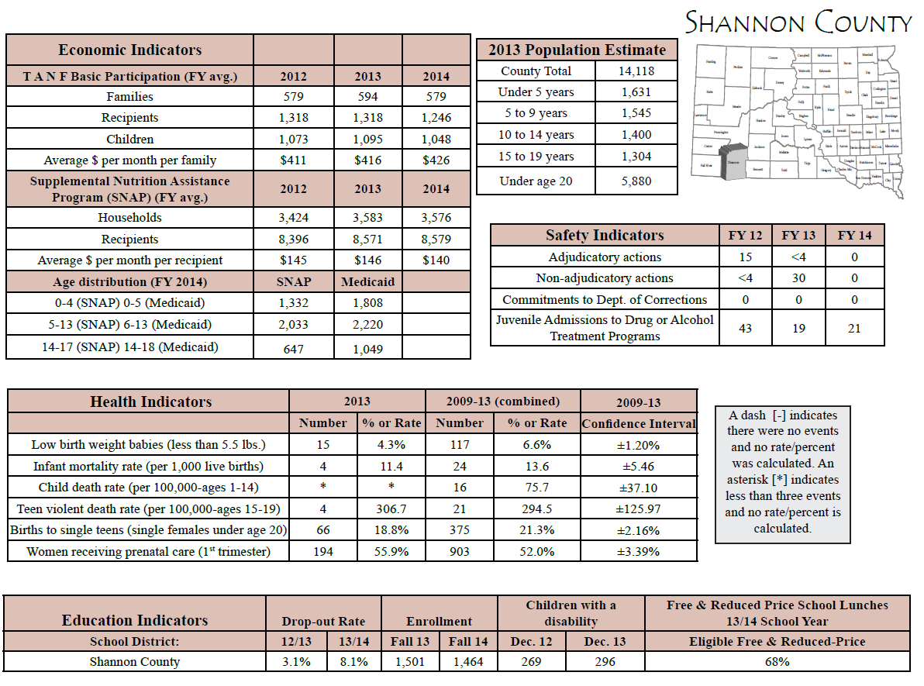

Summary of key findings (overall)
- TREC needs to focus on improving math and language scores for children in HS/EHS programs.
- TREC communities must focus on health and wellness for children and families enrolled in the program.
- TREC must focus on developing deeper and more meaningful relationships with community partners.
- TREC should explore the opportunity that child care partnerships provide for our organization.
- TREC must place increased emphasis on pre-natal mothers in order to have care provided in the first trimester of pregnancy.
- Butte County continues to grow. TREC should work on recruitment in all areas, and find opportunities to expand in Butte County.
- With many resources currently available for children and families, TREC should continue to act as a conduit of information when referring potential and enrolled families to programs that can be beneficial (e.g., Social Service programs).
- Mental health is a continued concern in many communities. TREC must help advocate for mental health services in all communities.

Goals derived

Appendix A – Gold aggregation Data

AGE | # | AREA | Fall  BELOW | Fall  MEET | Fall  EXCEED | # | Winter  Below | Winter  Meet | Winter  Exceed | Growth by Area of Development  of Widely Held Expectations
1-2 | 8 | Soc-Emot | 1-12.5% | 5-62.5 | 2-25.0% | 8 | 0-0.0% | 7-87.5% | 1-12.5% | 6.0 | 1-11 |  |  | Mtg |  |  | 50-74%
 | 8 | Physical | 2-25.0% | 3-37.5% | 3-37.5% | 8 | 0.0.0% | 5-62.5% | 3-37.5% | 5.6 | 1-7 |  |  | Mtg |  |  | 50-74%
 | 8 | Language | 2-25.0% | 6-75.0% | 0-0.0% | 8 | 1-1.25% | 6-75.0% | 1-12.5% | 5.3 | 1-10 |  |  | Mtg |  |  | 50-74%
 | 8 | Cognitive | 1-12.5% | 4-50.0% | 3-37.5% | 8 | 0-0.0% | 6-75.0% | 2-25% | 6.6 | 1-11 |  |  | Mtg |  |  | 50-74%
 | 8 | Literacy | 3-37.5% | 3-37.5% | 2-25.0% | 8 | 2-25.0% | 4-50.0% | 2-25% | 4.1 | 1-8 |  |  | Mtg |  |  | 50-74%
 | 8 | Mathematics | 3-37.5% | 5-62.5% | 0-0.0% | 8 | 4-50.0% | 3-37.5% | 1-12.5% | 5.3 | 1-6 |  |  | Mtg |  |  | 50-74%
AGE | # | AREA | Fall  BELOW | Fall  MEET | Fall  EXCEED | # | Winter  Below | Winter  Meet | Winter  Exceed | Growth by Area of Development  of Widely Held Expectations
2-3 | 16 | Soc-Emot | 3-18.8% | 6-37.5% | 7-43.8% | 16 | 3-18.8% | 11.68% | 2-12.5% | 1.7 | 1-12 |  |  |  |  | Mtg |  | 25-49%
 | 16 | Physical | 3-18.8% | 6-37.5% | 7-43.8% | 16 | 5-31.3% | 9-56.3% | 2.12.5% | 0.4 | 1-6 |  |  |  |  | Not Mtg |  | 0-24%
 | 15 | Language | 7-46.7% | 2-13.3% | 6-40.0% | 15 | 4-26.7% | 9-60.0% | 2-13.3% | 1.7 | 1-10 |  |  |  |  | Mtg |  | 25-49%
 | 16 | Cognitive | 3-18.8% | 6-37.5% | 7-43.8% | 16 | 3-18.8% | 11-68.8% | 2-12.5% | 2.7 | 1-12 |  |  |  |  | Mtg |  | 25-49%
 | 14 | Literacy | 4-28.6% | 4-28.6% | 6-42.9% | 14 | 3-21.4% | 11-78.6% | 0-0.0% | 2.7 | 1-11 |  |  |  |  | Mtg |  | 25-49%
 | 14 | Mathematics | 4-28.6% | 5-37.5% | 5-35.7% | 14 | 2-14.3% | 12-85.7% | 0-0.0% | 2.7 | 1-8 |  |  |  |  | Mtg |  | 25-49%
AGE | # | AREA | Fall  BELOW | Fall  MEET | Fall  EXCEED | # | Winter  Below | Winter  Meet | Winter  Exceed | Growth by Area of Development  of Widely Held Expectations
3 | 24 | Soc-Emot | 7-29.2% | 16-66.7% | 1-4.2% | 24 | 1-4.2% | 21-87.5% | 2-8.3% | 7.3 |  | 1-15 |  | Mtg |  |  | 25-49%
 | 25 | Physical | 1-4.0% | 23-92.7% | 1-4.0% | 25 | 1-4.0% | 20-80.0% | 4-16.0% | 3.2 |  | 1-7 |  | Mtg |  |  | 25-49%
 | 25 | Language | 4-16.0% | 20-80.0% | 1-4.0% | 27 | 4.14.8% | 21-77.8% | 2-7.4% | 5.9 |  | 2-14 |  | Mtg |  |  | 25-49%
 | 27 | Cognitive | 4-14.8% | 22-81.5% | 1-3.7% | 27 | 4-14.8% | 21-77.8% | 2-7.4% | 5.9 |  | 2.14 |  | Mtg |  |  | 25-49%
 | 25 | Literacy | 12-48.0% | 12-48.0% | 1-4.0% | 25 | 2-8.0% | 22-88.0% | 1-4.0% | 8.5 |  | 3-17 |  | Mtg |  |  | 25-49%
 | 25 | Mathematics | 12-48.0% | 12-48.0% | 1-4.0% | 25 | 5-20.0% | 18-72.0% | 2-8.0% | 5.72 |  | 2-11 |  | Mtg |  |  | 25-49%
AGE | # | AREA | Fall  BELOW | Fall  MEET | Fall  EXCEED | # | Winter  Below | Winter  Meet | Winter  Exceed | Growth by Area of Development  of Widely Held Expectations
4 | 29 | Soc-Emot | 8-27.6% | 21-72.4% | 0-0.0% | 29 | 0-0.0% | 25-86.2% | 4-13.8% | 6.7 |  |  | 2-15 |  | Mtg |  | 25-40%
 | 28 | Physical | 6-21.4% | 22-78.6% | 0.0.0% | 28 | 0-0.0% | 28-100% | 0-0.0% | 3.7 |  |  | 1-8 |  | Mtg |  | 25-49%
 | 29 | Language | 3-10.3% | 26-89.7% | 0-0.0% | 29 | 0-0.0% | 27-93.1% | 2-6.9% | 6.6 |  |  | 1-12 |  | Mtg |  | 50-74%
 | 29 | Cognitive | 1-3.4% | 28-96.6% | 0.0.0% | 29 | 0-0.0% | 29.100% | 0-0.0% | 7.8 |  |  | 2-15 |  | Mtg |  | 25-49%
 | 27 | Literacy | 4-14.8% | 23-85.2% | 0-0.0% | 27 | 0-0.0% | 26.96.3% | 1-3.7% | 12.0 |  |  | 4-20 |  | Mtg |  | 50-74%
 | 28 | Mathematics | 13-46.4% | 15-53.6% | 0.0.0% | 28 | 6-21.4% | 19-67.9% | 3-10.7% | 7.4 |  |  | 2-12 |  | Mtg |  | 50-74%

The number of estimated children was calculated from data obtained from the U.S. Census and American Community Survey.
In addition, the estimated number was derived from the following equation: Total county population multiplied by the % of population under 5. This gives you the number of children less than 5 years of age. Multiplying the number of children less than 5 years by the poverty percentage equals the number of children less than 5 years of age that are in poverty. Add 10% for over-income to arrive at HS/EHS eligible.
Source: South Dakota Department of Education. 2012 – 2013 was the most recent year 3rd grade assessments were administered. Because of the transition to the Smarter Balanced Assessment, no scores were recorded in the 2013 – 2014 school year.
‘-‘ denotes there were not enough students to report data publicly (n<10)
TREC’s Birth to Three partners are Black Hills Birth to Three Connections, Northwest Area Birth to Three Connections, and Oglala Sioux Tribe Early Intervention

